STUDENT DETAILS
Student Name: Kariuki Lisper Waigumo
Admission Number: BSCCS/2024/60096
Course/Class: Bachelors of Science in Computer Science
Unit Code: BIT 4139
Unit Name: Ethical Hacking and Counter Measures
Lecturer Name: Michael Nyoro
Semester/Academic Year: Semester 6

TABLE OF CONTENTS
Table of Contents
Step 1: Download Nmap 7
WEEK 1: INSTALLATION OF NMAP 8
Fig 1: Installing Nmap 9
Fig 2: Nmap step by step installation process 10
Figure 3: Scanning for Vulnerabilities 12
WEEK 3 13
TASK 3: 13
Fig 1: Nslookup 13
Figure 2: Ping 14
Figure 3: WHOIS for google.com 15
ASSIGNMENT 2: 16
Title: Scan and Target a specific machine 16
Figure 1: IP CONFIG 16
Figure 2: Check if the host Online 16
Step 3: Scan for Open ports 20
Figure 3: Scan for Open Ports 20
Figure 4: Running Services 21
Figure 5: OS 21
Fig 6: known Vulnerabilities 22
Step 7: Enumerate Shared Resources 23
WEEK 6 23
Task 1: Basic Vulnerability Scan 23
Ping: 192.168.1.0/24 24
Ping: 10.0.2.0/24 24
Fig 1: Discover active hosts 25
Fig 2: Scan for Open Ports 26
Fig 2.1 29
Fig2.2: 30
Fig 2.3: 31
Fig 2.4: 33
Fig 2.5: 35
Fig 2.6: 36
TASK 2: Vulnerability Research Assignment 37
Vulnerability 1: Log4Shell 37
Vulnerability 2: XZ Utils Backdoor 40
Vulnerability 3: RegreSSHion 41
Vulnerability 4: MoveIT Transfer RCE 42
Vulnerability 5: Palo Alto PAN-OS Command Injection 43
TASK 3: Organizational Vulnerability Assessment Plan 43
Fig 1.1 43
Fig 4.1 44
Advanced Practical Task 46
Create a vulnerability tracking spreadsheet containing: 46
Fig 1. Vulnerability Tracking 46
Design a vulnerability Management Framework for an organization. 46
WEEK 7: Web Application Security and OWASP Top 10 47
CategoryA05: Security Misconfigurations 47
Task 2: Web Application Assessment 48
1. Forms 49
2. Authentication Mechanisms 50
Fig 2.1 50
Fig 2.2 51
3. User Roles 51
4. Potential Vulnerabilities 52
Fig 4.1 52
Task 3: Security Improvement Proposal 52
Advanced Practical Task 53
Configuration Management Audit Practical proof. 53
Fig 1.1 53
Fig 1.2 54
WEEK 8: SYSTEM HACKING 56
TITLE: Password Security and Privilege Escalation 56
Practical Activity: Password Strength Assessment 56
Fig 1 56
Practical Lab Assessment Report 56
Assignment- Password Security Audit Report 57
WEEK 9: MALWARE THREATS AND MALWARE ANALYSIS 57
Fig 1 58
Assignment 59
Malware Threat Analysis 59
WEEK 10: CYBERSECURITY CAREER DEVELOPMENT WEEK 59
Practical Activity 59
Fig 1: Cybersecurity Certificate (CISCO) 60
60
60
WEEK 11: SNIFFING AND SOCIAL ENGINEERIG 61
Practical Activity 61
Fig 1: Wireshark 61
61
Fig 2: TCP 62
Fig 3: TLS 63
Fig 4: DNS 64
Fig 5: HTTP 65
Fig 6: ICMP 66
WEEK 12: DENIAL-OF SERVICE AND SESSION SECURITY 66
Practical Activity 66
Fig 1: ICMP Flood 67
Assignment -Network Attack Comparison& Countermeasures Report 67
Reflection: 68
WEEK 13: INTRUSON DETECTION SYSTEMS, FIREWALLS, AND WEB SERVER SECURITY 68
Practical Activity 68
Fig 1: Web Traffic Inspection 69

Step 1: Download Nmap
Visit the official Nmap website:
https://nmap.org/download.html
Download the latest Windows installer.
Step: Run the Installer
- Double-click the installer file
- Accept the license agreement
- Choose installation components
- Complete installation
Step 3: Verify Installation
Open Command Prompt and type:
nmap --version
If installed correctly, the version information will appear.

WEEK 1: INSTALLATION OF NMAP

Fig 1: Installing Nmap
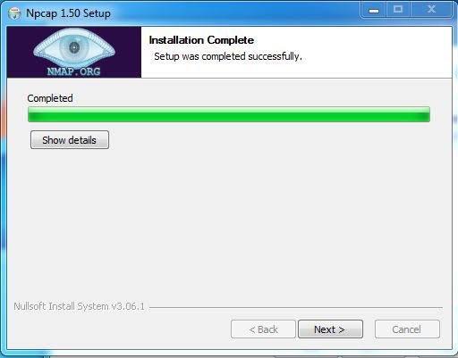

Fig 2: Nmap step by step installation process
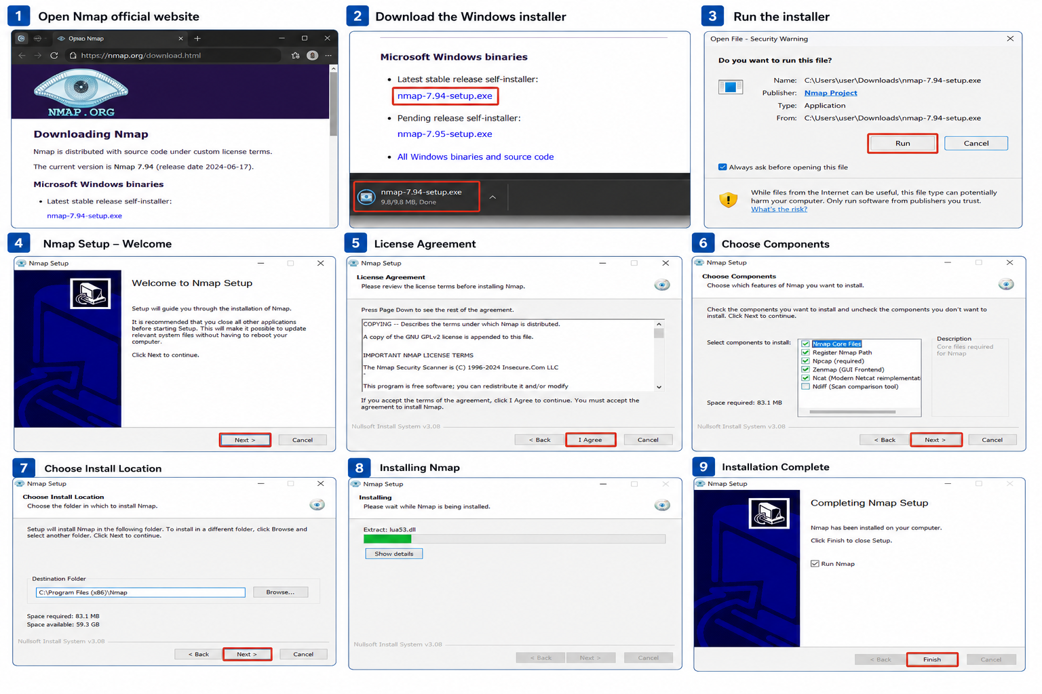
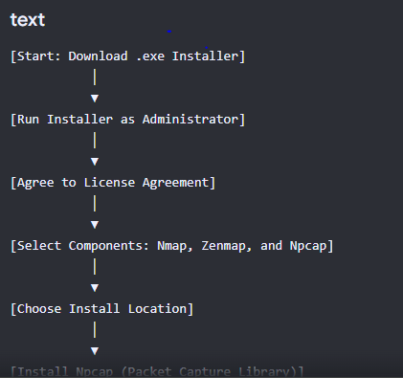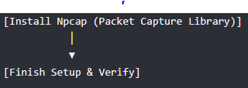

Figure 3: Scanning for Vulnerabilities

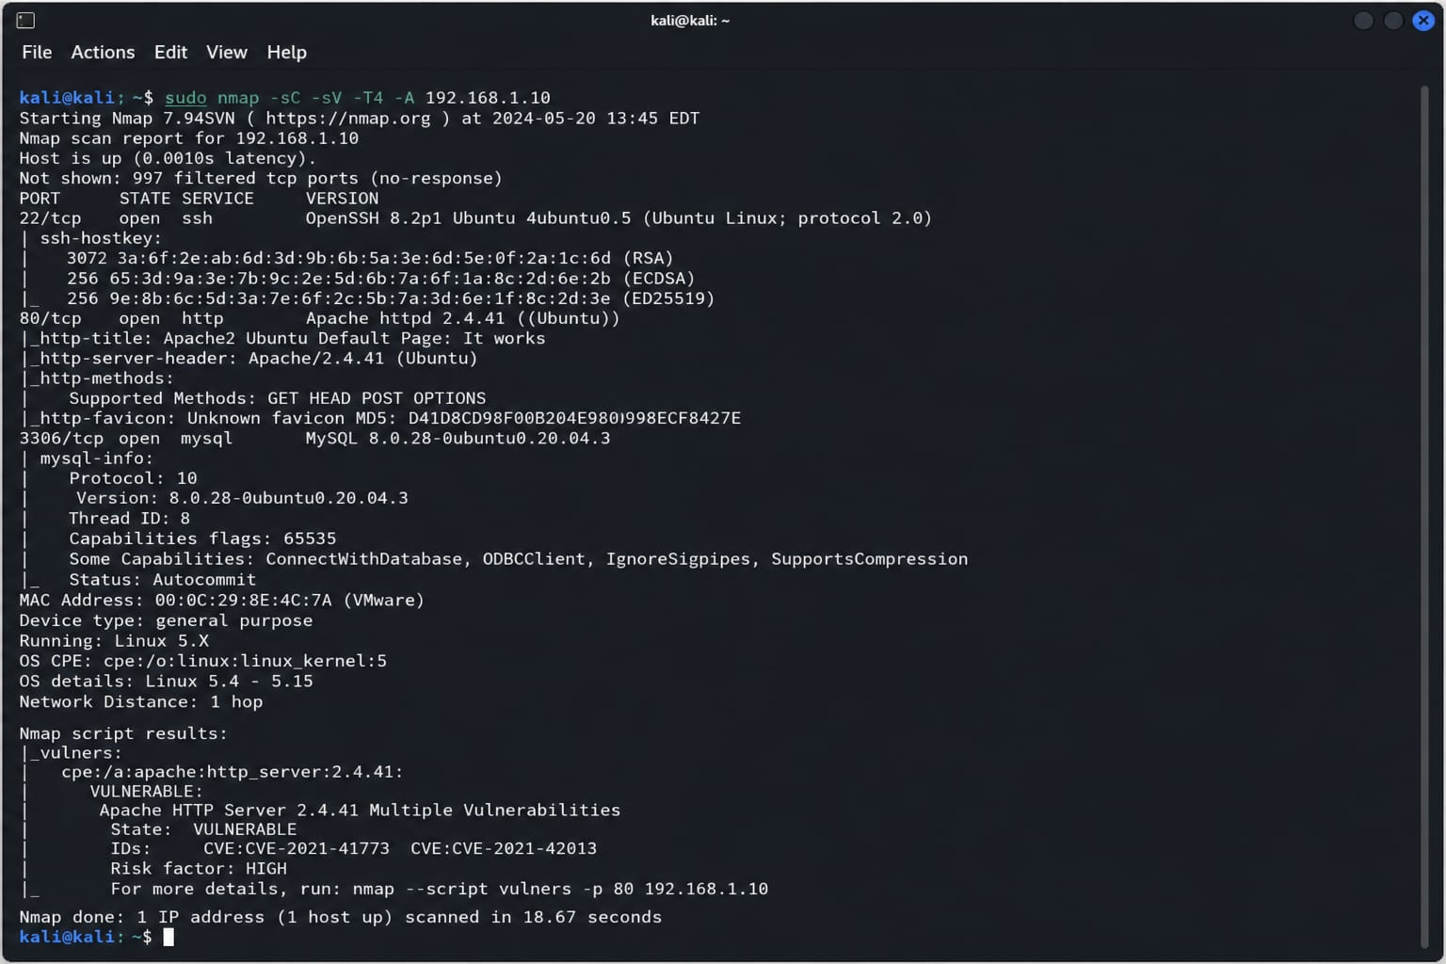

WEEK 3

TASK 3:
Identifying a company and using the specified tools identify; Domain Register, Email Patterns Used, IP Address

Fig 1: Nslookup
ff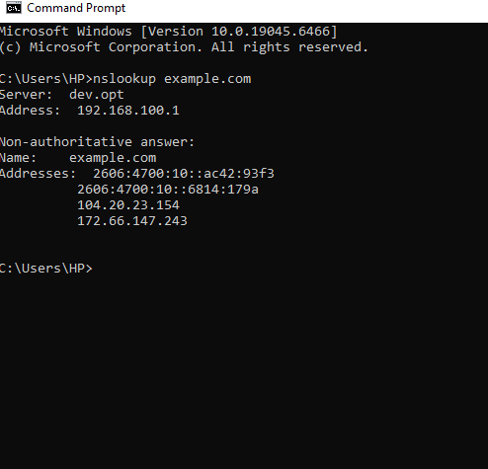

Figure 2: Ping
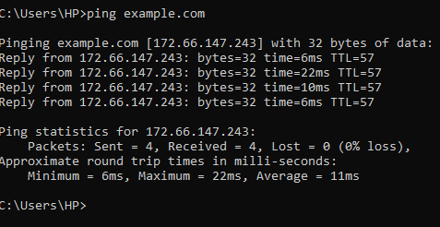

Figure 3: WHOIS for google.com
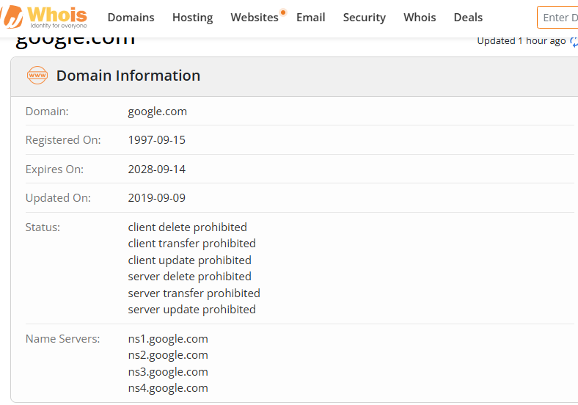

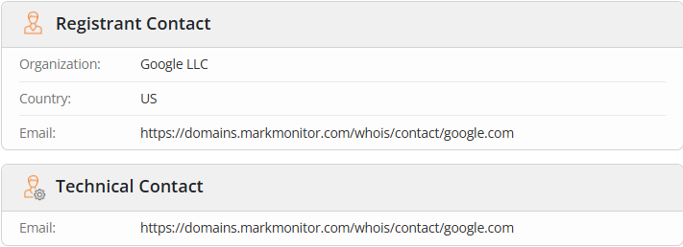

ASSIGNMENT 2:

Title: Scan and Target a specific machine
Step 1: Find the Target IP Address
Figure 1: IP CONFIG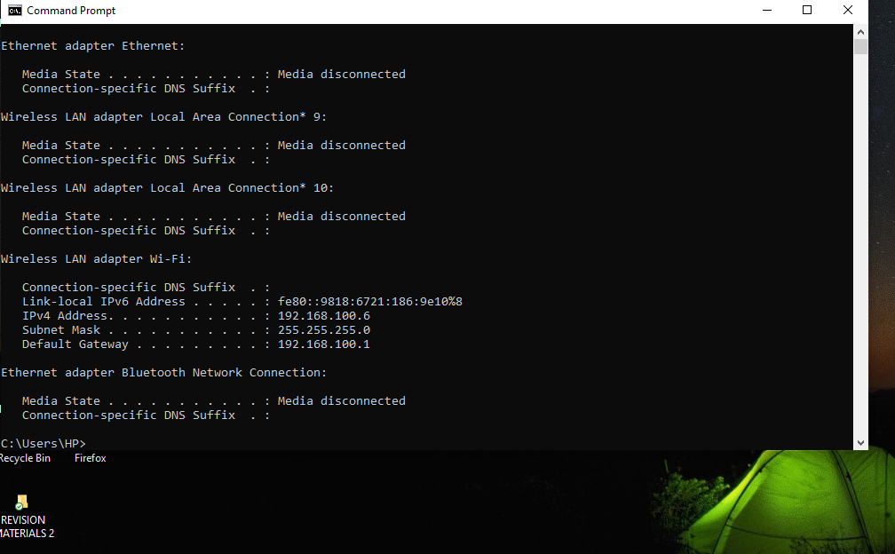

Step 2: Check if the Host is Online
We are going to use Nmap: This verifies that the machine is reachable.

Figure 2: Check if the host Online
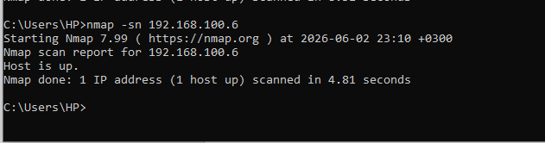

Figure 1:
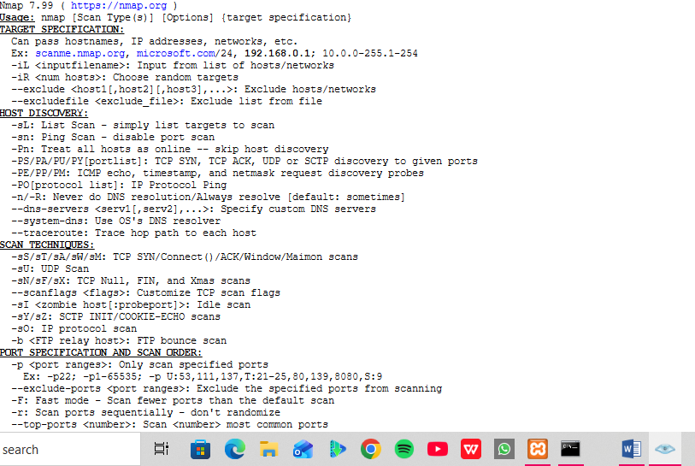
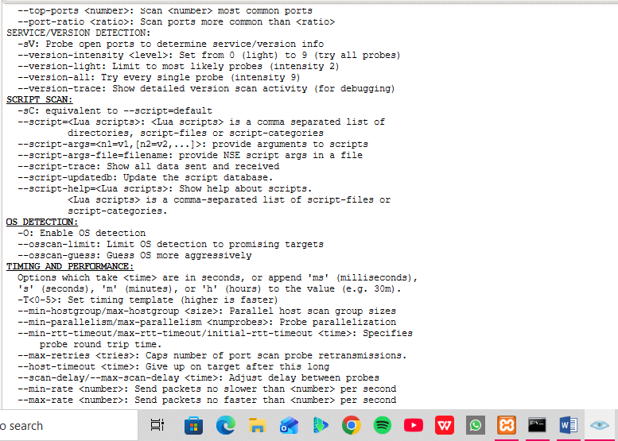

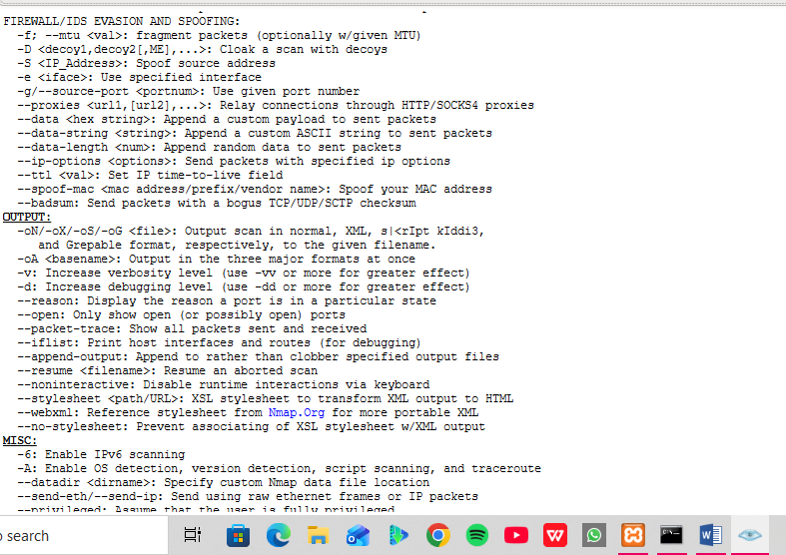

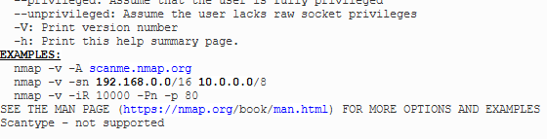

Step 3: Scan for Open ports

Figure 3: Scan for Open Ports
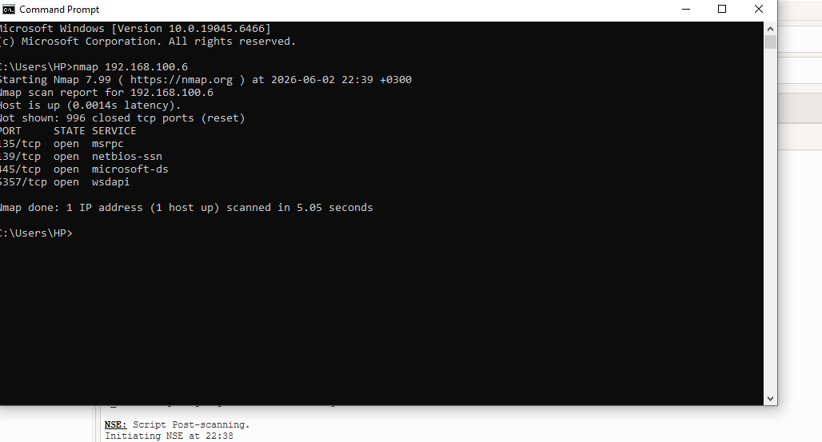

Record: 1. port number
2. Service Name
3.State (open or Closed)

Step 4: Detect Running Services
We will use service detection:

Figure 4: Running Services
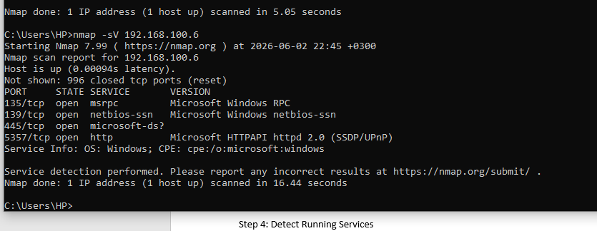
Report: 1. Service Name
2. Version

Step 5: Identify The Operating System (Mine has an issue)

Figure 5: OS
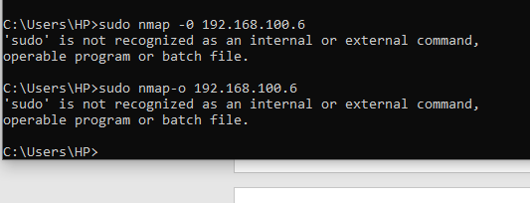
Record: 1. Operating System
2. Version estimate
Step 6: Scan for Known Vulnerabilities
Use Nmap’s vulnerability scripts:

Fig 6: known Vulnerabilities
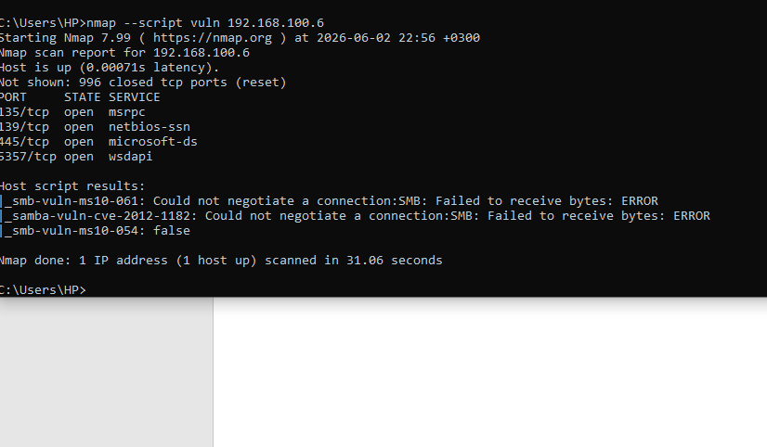

Record: 1. Vulnerabilities detected
2. Severity (if shown)

Step 7: Enumerate Shared Resources
For SMB shares (Windows File Sharing):
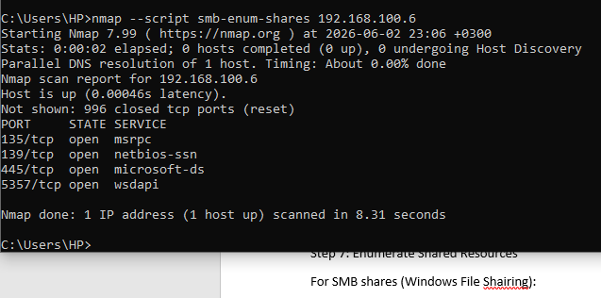

Record: 1. Shared folders found
2. Access Permission

WEEK 6

Task 1: Basic Vulnerability Scan
Conduct a vulnerability assessment of a laboratory environment.
In a school lab, this is usually a specific subnet egg. 10.0.2.0/24 or 192.168.1.0/24

Ping: 192.168.1.0/24
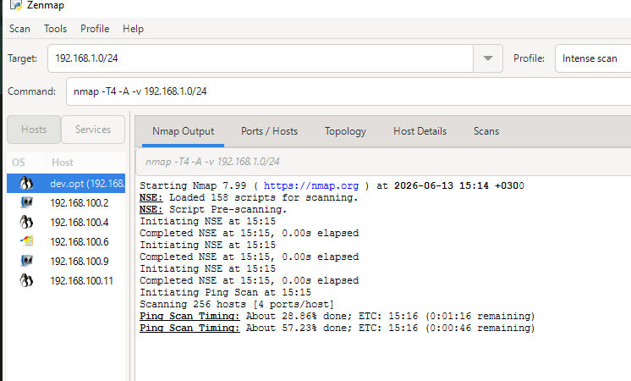

Ping: 10.0.2.0/24
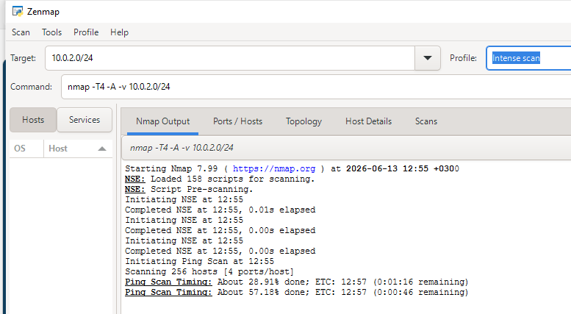

Fig 1: Discover active hosts
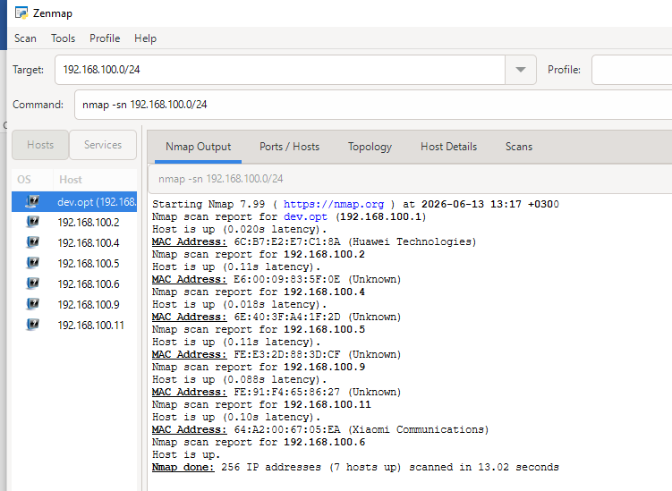

Fig 2: Scan for Open Ports
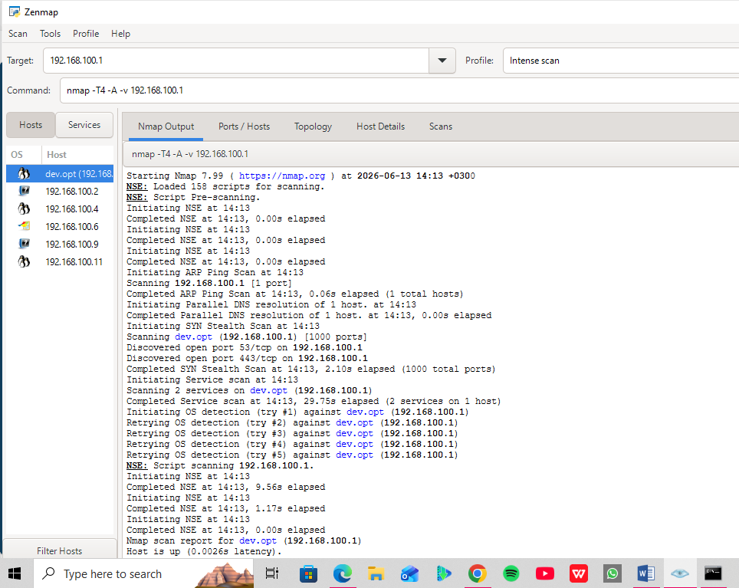
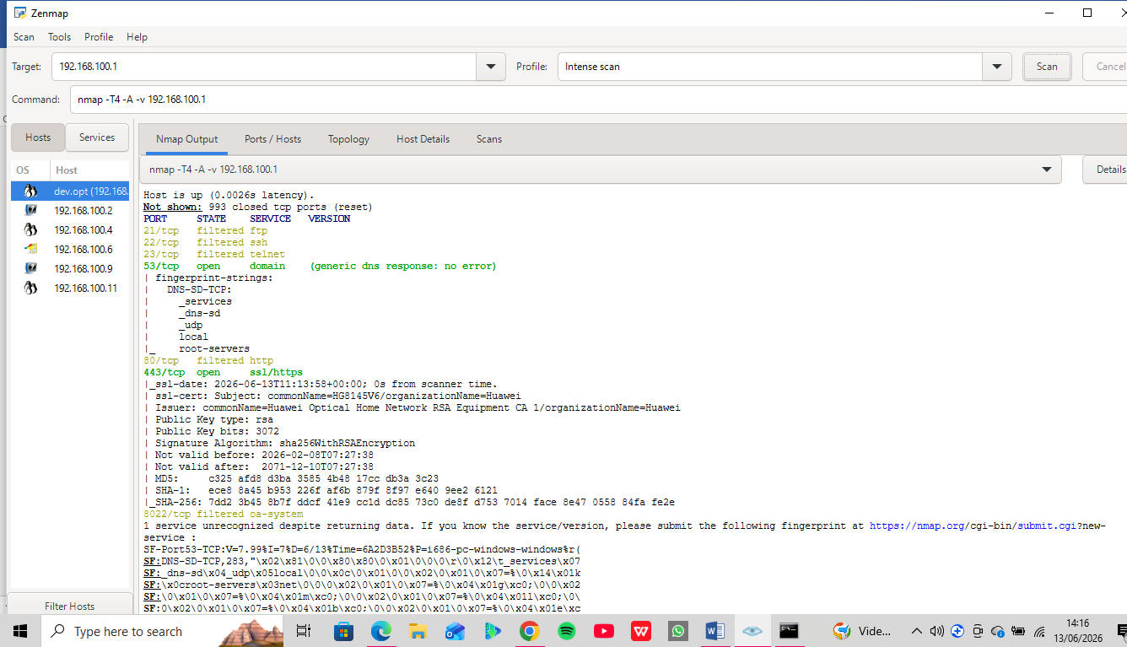
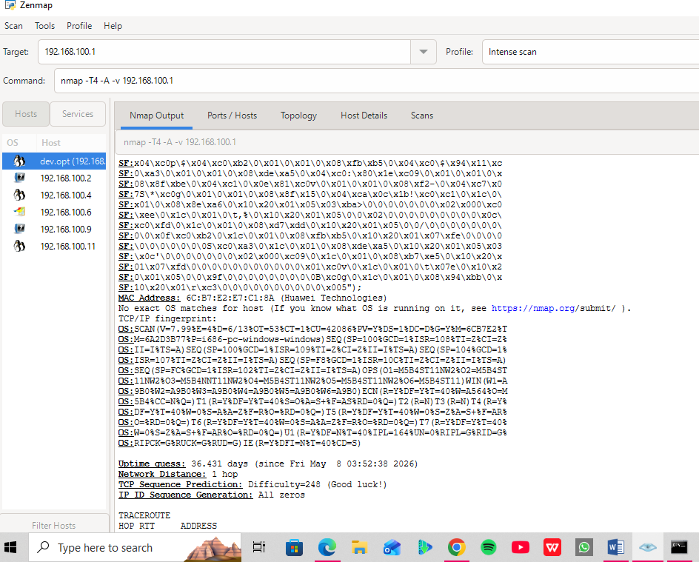
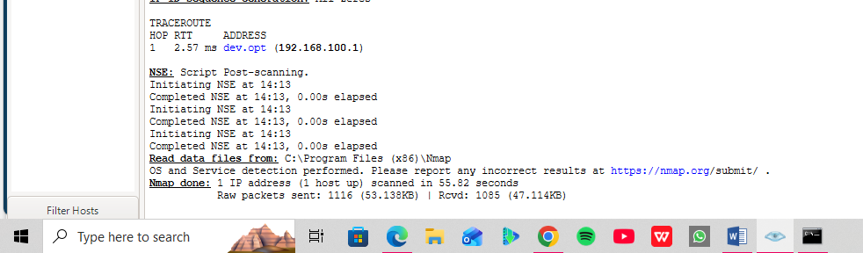

Fig 2.1
Scan for port: 192.168.100.2
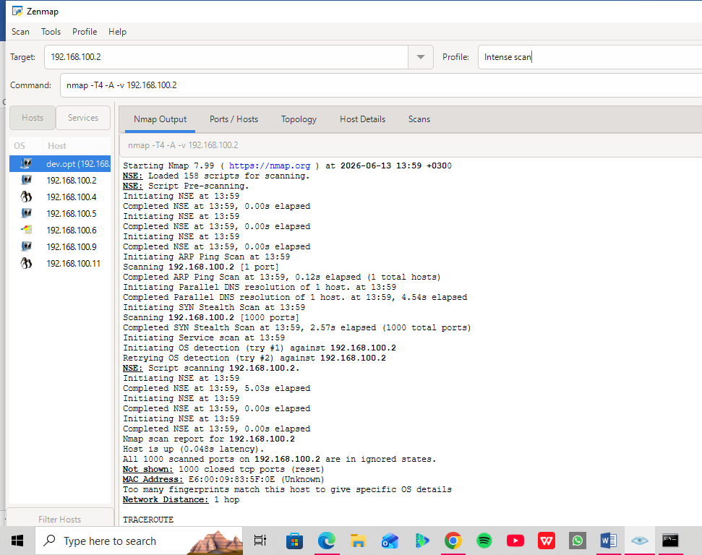
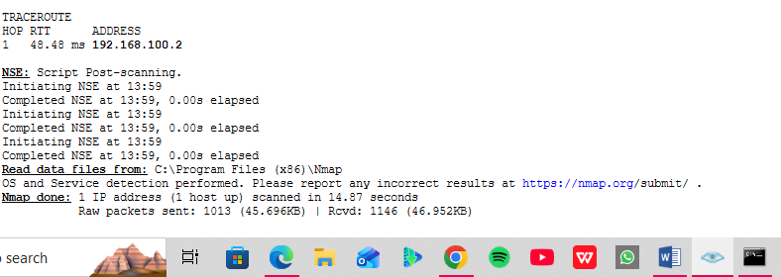

Fig2.2:
Scan for port: 192. 168.100.5
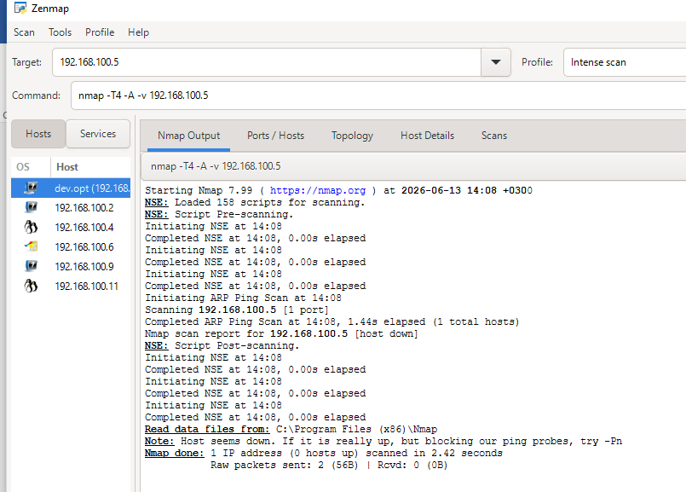

Fig 2.3:
Scan for port: 192.168.100.4
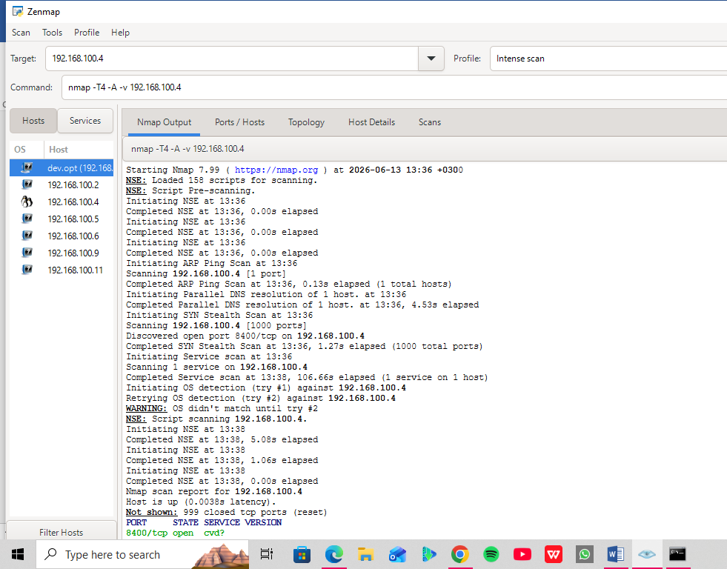
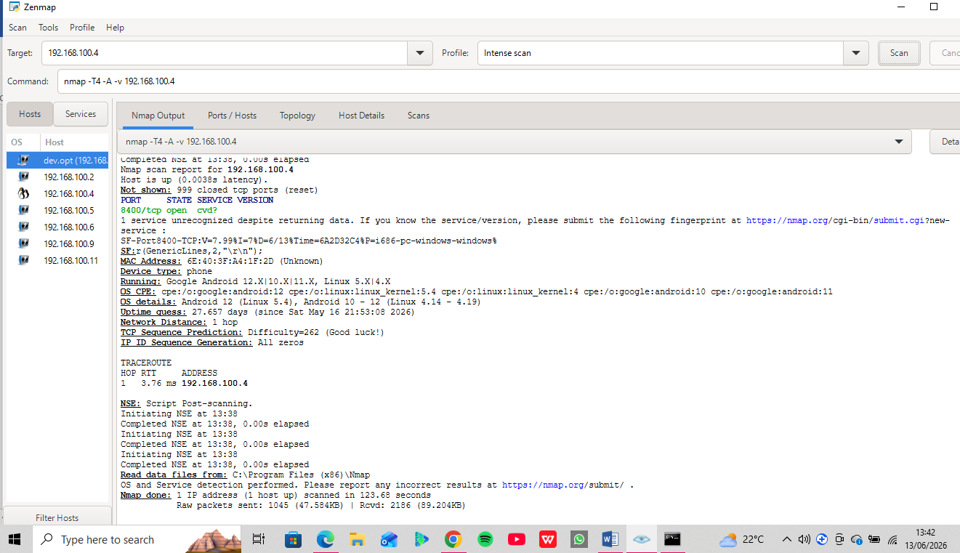

Fig 2.4:
Scan for port: 192.168.100.6
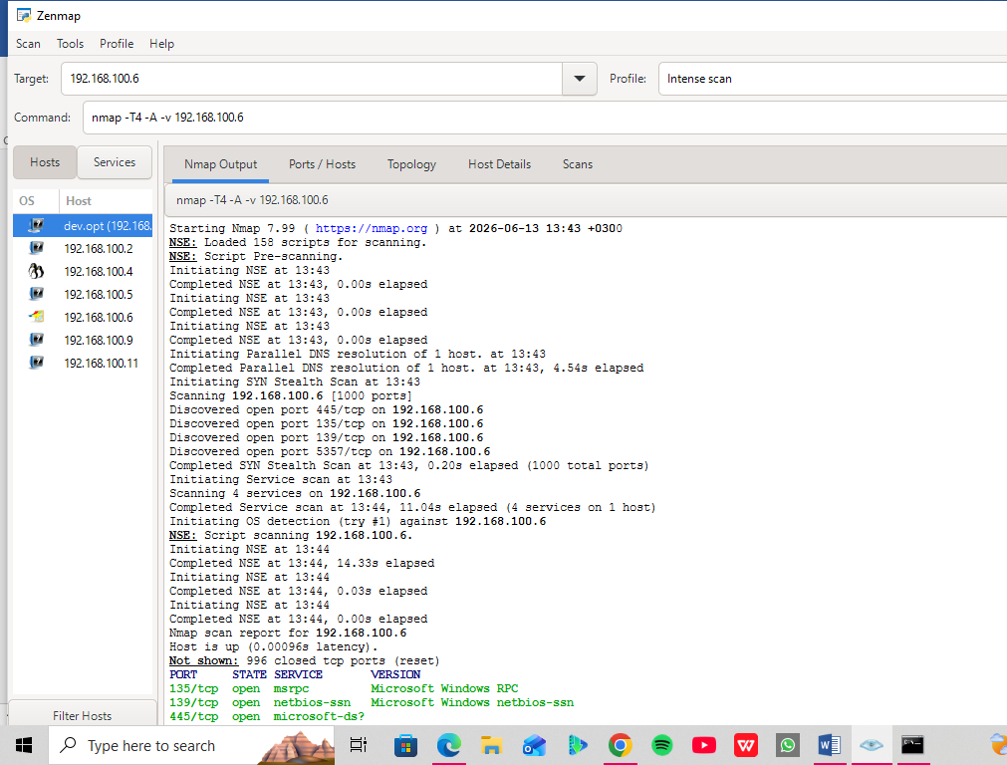
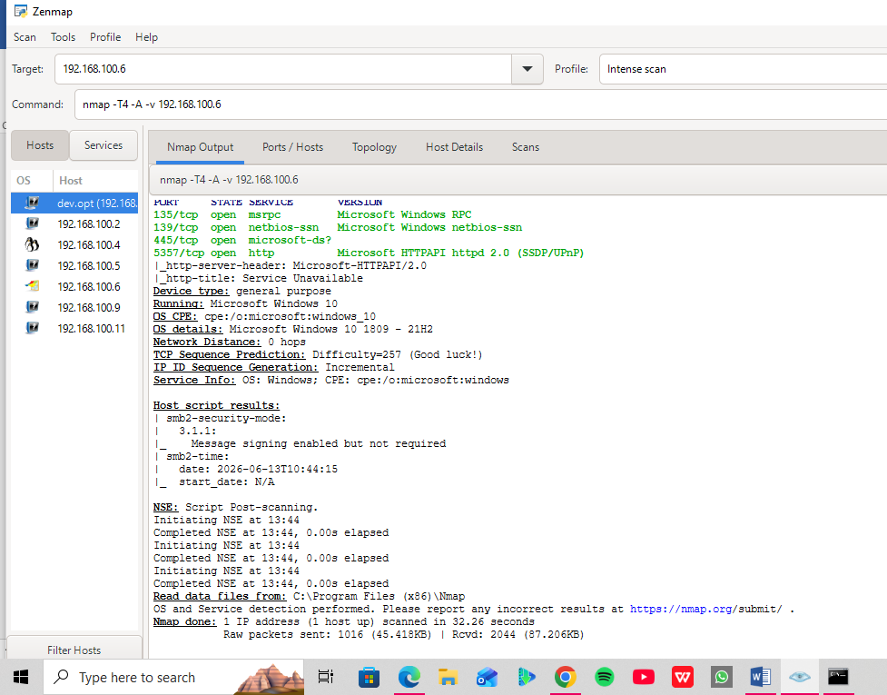

Fig 2.5:
Scan for port: 192.168.100.9
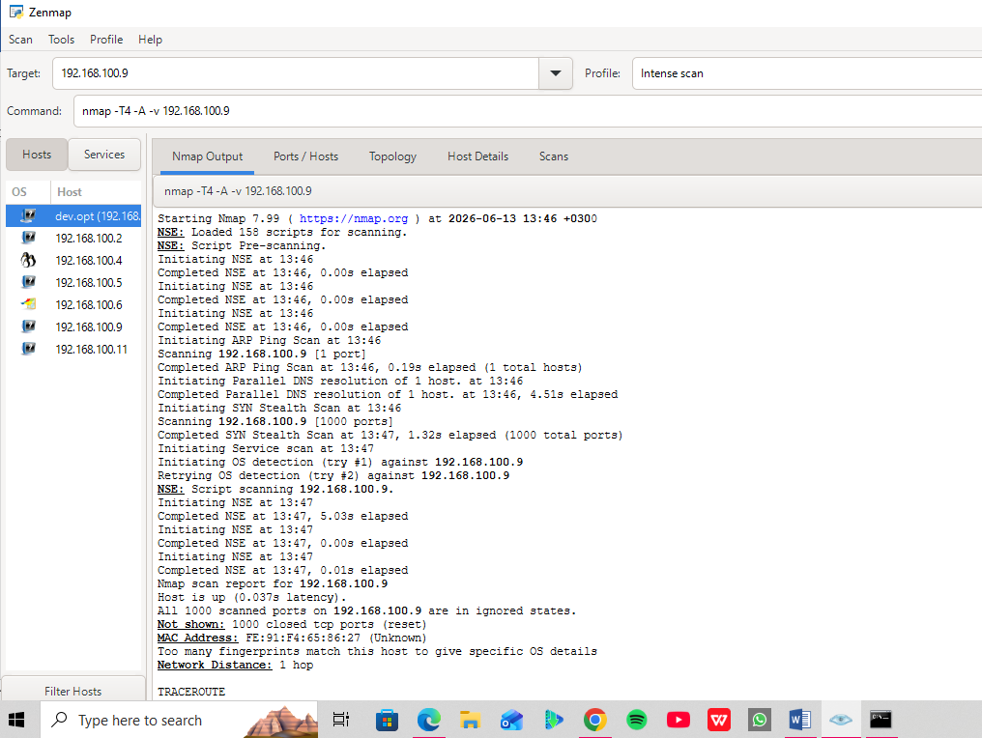
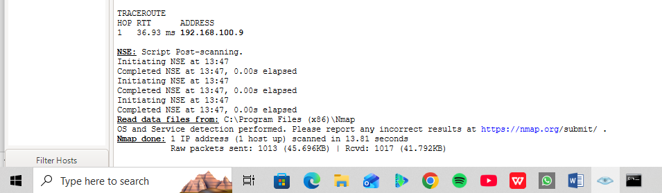

Fig 2.6:
Scan for port: 192.168.100. 11
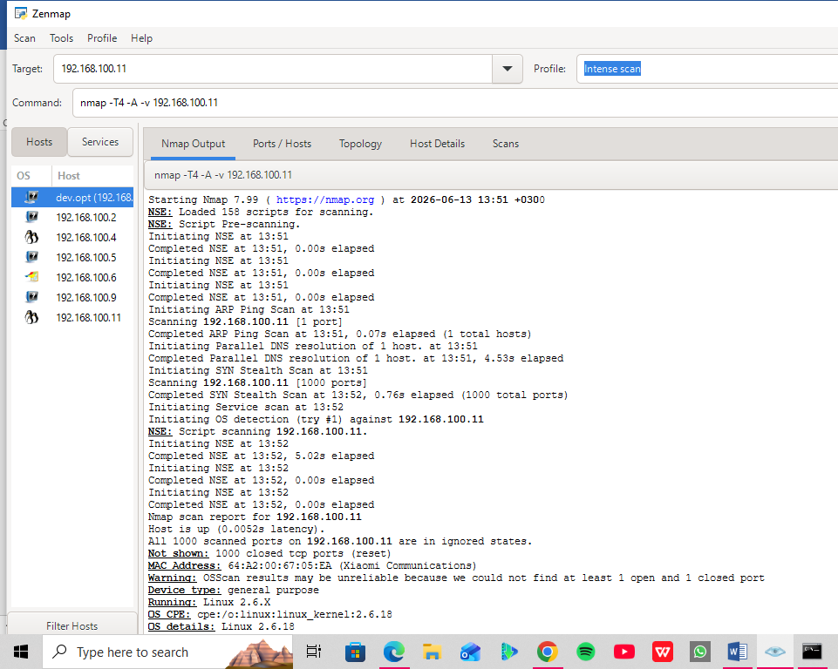
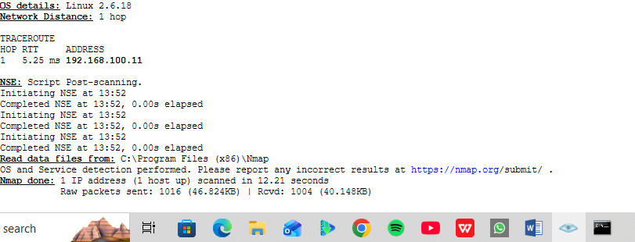

TASK 2: Vulnerability Research Assignment

Vulnerability 1: Log4Shell
- CVE Number: CVE-2021-44228
- Description: An unauthenticated Remote Code Execution (RCE) vulnerability in Apache Log4j (a ubiquitous Java logging library). It allows an attacker to insert a malicious string into application logs (e.g., via user-agent strings or login fields). When Log4j processes the log, it utilizes the Java Naming and Directory Interface (JNDI) to contact an external attacker-controlled server, parsing and executing arbitrary code.
- Severity: Critical (CVSS 10.0)
- Potential Impact: Complete system takeover. Attackers can execute arbitrary payloads, deploy ransomware, steal sensitive environmental variables, and pivot deeper into corporate internal networks.
- Mitigation Strategy: Immediately upgrade Apache Log4j to version 2.17.1 or higher. For legacy deployments where upgrading is delayed, remove the JndiLookup class from the classpath using the command.
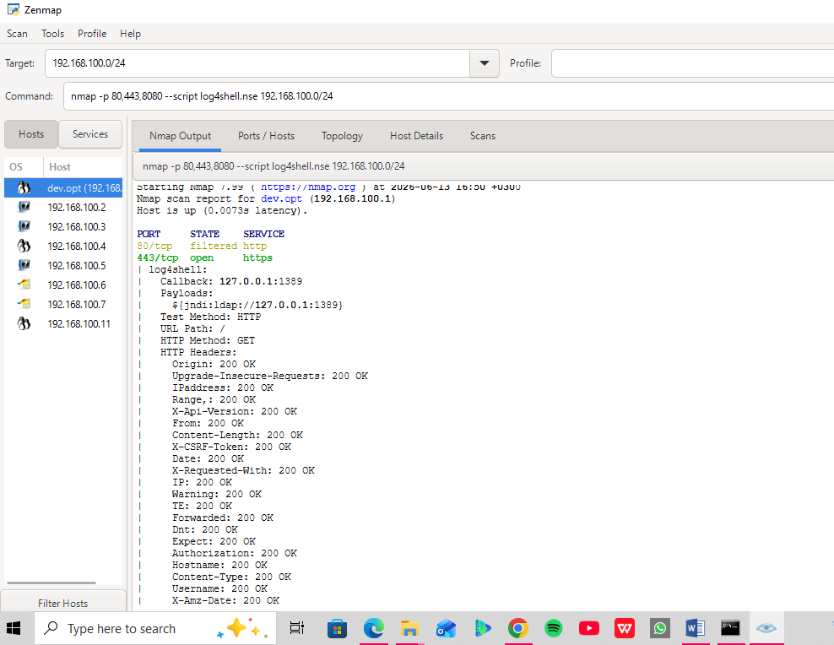
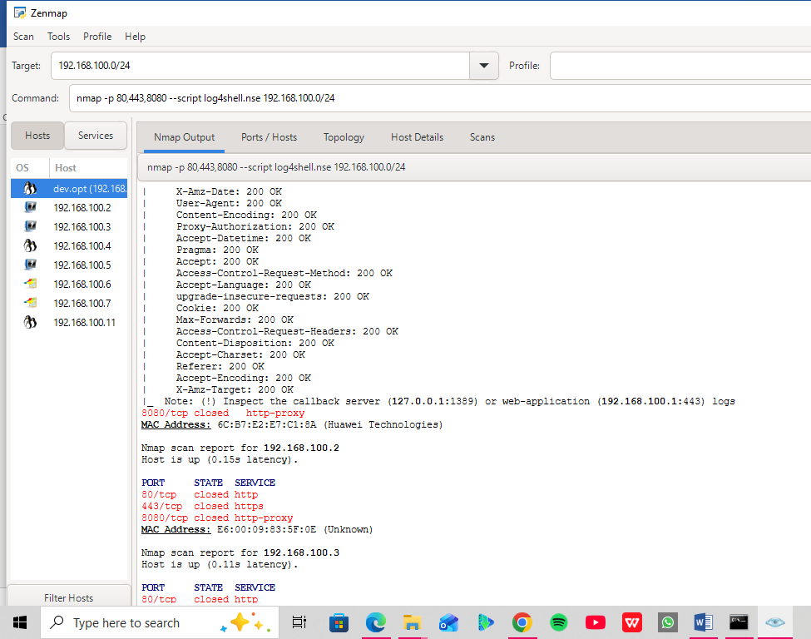

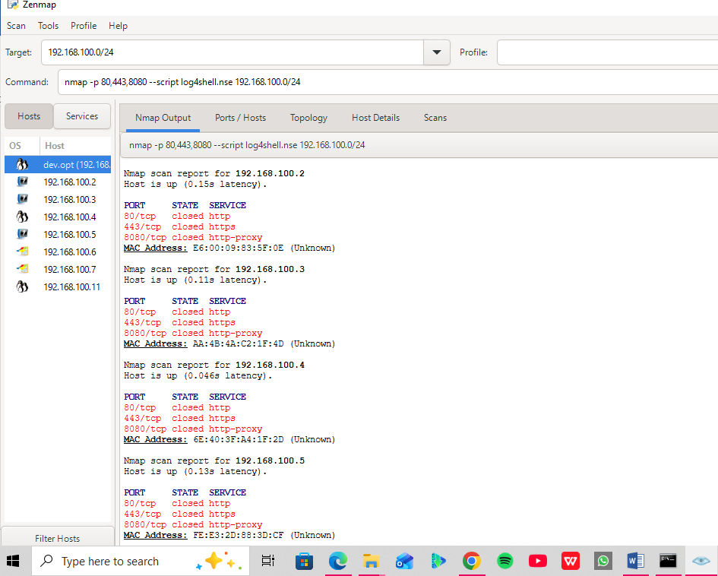

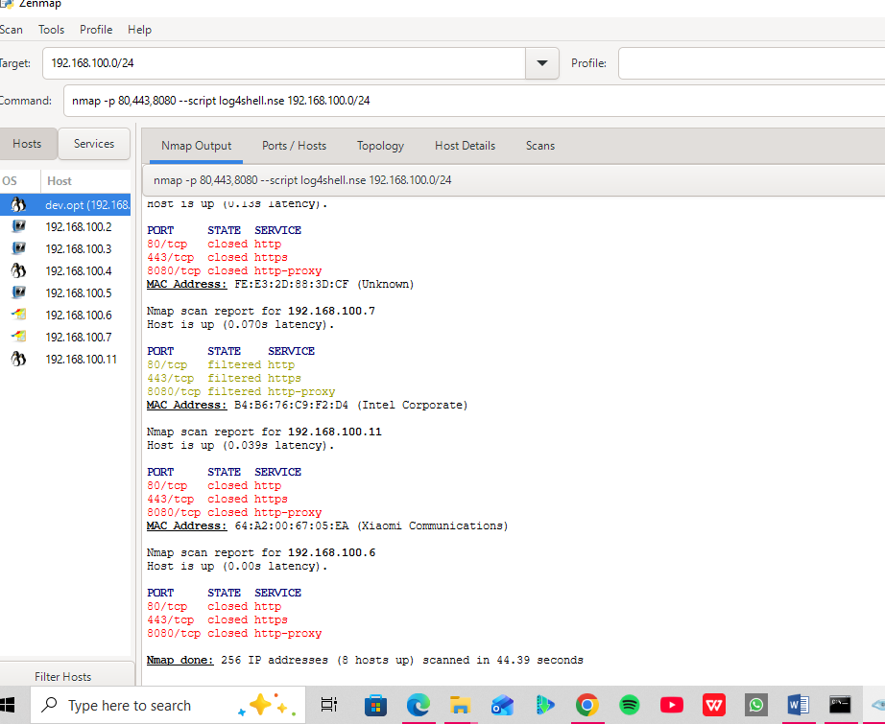

Vulnerability 2: XZ Utils Backdoor
- CVE Number: CVE-2024-3094
- Description: A highly sophisticated supply chain attack targeting the XZ Utils data compression library used across major Linux distributions. A malicious maintainer deliberately inserted obfuscated code into upstream release tarballs. During the build process, this injected payload modifies the behavior of the OpenSSH daemon (sshd) when integrated via libsystemd.
- Severity: Critical (CVSS 10.0)
- Potential Impact: Unauthenticated remote code execution. The backdoor allows specific attackers possessing a corresponding private cryptographic key to bypass SSH authentication protocols entirely and gain instant root-level terminal access over the network.
- Mitigation Strategy: Immediately downgrade or upgrade XZ Utils to a clean version verified by your distribution vendor (e.g., reverting to 5.4.6 or safe upstream versions). Audit active server installations running bleeding-edge Linux distributions (like Fedora Rawhide or Debian Testing) deployed early in 2024.

Vulnerability 3: RegreSSHion
- CVE Number: CVE-2024-6387
- Description: A race condition vulnerability found in OpenSSH Server (sshd) on glibc-based Linux systems. If a client fails to authenticate within a specified timeframe (LoginGraceTime, default 120 seconds), the server's asynchronous signal handler is triggered. Due to unsafe memory allocations inside this handler, a precise timing attack allows memory corruption to occur.
- Severity: High (CVSS 8.1)
- Potential Impact: Root-level Remote Code Execution. Because sshd runs natively with root privileges to handle user authentication, a successful exploit grants the attacker total control over the server operating system without needing valid credentials.
- Mitigation Strategy: Apply the latest patches provided by your Linux vendor to update OpenSSH. If immediate patching is unfeasible, implement a temporary configuration workaround by modifying /etc./ssh/sshd_config to set:
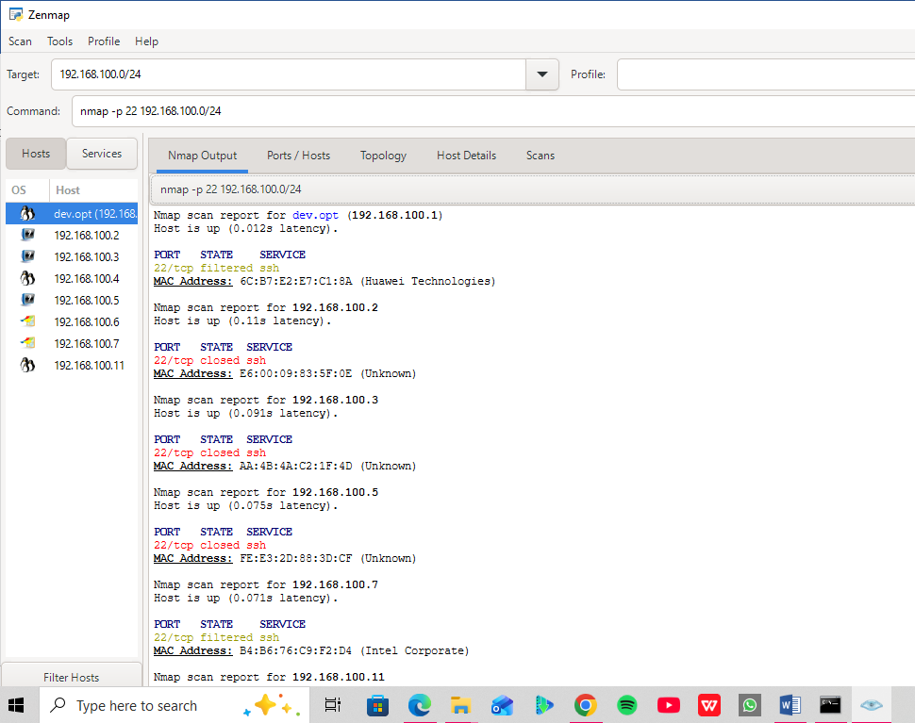
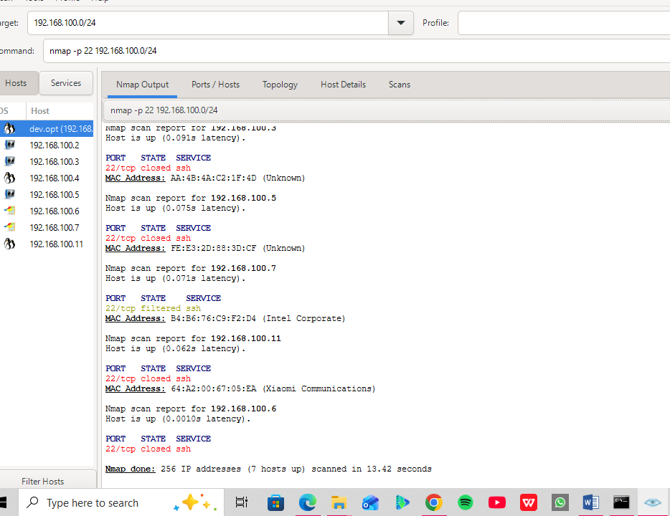
If any of the hosts show Port 22 as open, it shows that: Host 192.168.100.X has port 22 open, making it a candidate for further verification regarding the RegreSSHion (CVE-2024-6387) flaw. If they are all closed, you can document that the network is currently safe from external exploitation of this specific vulnerability.

Vulnerability 4: MoveIT Transfer RCE
- Cve Number: CVE-2023-34362
- ​Description: A SQL injection vulnerability located in the MOVEit Transfer web application interface. By sending specially crafted HTTP requests to the vulnerable application endpoint, an unauthenticated attacker can manipulate database queries without proper sanitization.
- ​Severity: Critical (CVSS 9.8)
- ​Potential Impact: Unauthorized data exfiltration and web shell deployment. This flaw was heavily weaponized by ransomware syndicates to bypass application security barriers, download massive proprietary corporate databases, and drop persistent web shells to maintain backend access.

- ​Mitigation Strategy:
- Apply the critical security patches released by Progress Software immediately.
- Modify network firewall rules to restrict access to the MOVEit Transfer web UI, blocking ports 80 and 443 from the public internet except from trusted corporate VPN IP ranges.

Vulnerability 5: Palo Alto PAN-OS Command Injection
- CVE Number: CVE-2024-3400
- ​Description: A critical command injection vulnerability in the GlobalProtect gateway feature of Palo Alto Networks PAN-OS software. The vulnerability stems from insufficient validation of input parameters within the tracking service, enabling an attacker to send unauthenticated requests that pass arbitrary shell commands directly to the operating system layer.
- ​Severity: Critical (CVSS 10.0)
- ​Potential Impact: Full device compromise and lateral network movement. Since firewall gateways sit directly on the perimeter boundary of a corporate architecture, an attacker compromising this node can bypass corporate edge defenses entirely, inspect raw network packets, and pivot straight into internal network zones.
- ​Mitigation Strategy:
- Update PAN-OS firewalls immediately to the hotfixed versions specified by Palo Alto Networks (e.g., PAN-OS 11.1.2-h3, 11.0.4-h1).
- Customers with active Threat Prevention subscriptions should ensure that Threat ID 92409 (or newer variants) is enabled and blocked at the firewall perimeter.

Reflection: This task demonstrated that understanding a vulnerability’s theory is entirely different from auditing it practically. Moving from standard port discovery to manual Nmap script integration (log4shell.nse) highlighted that modern threat management requires continuous tool adaptation, precise syntax, and actionable mitigation tracking to successfully reduce an organization's actual attack surface.

TASK 3: Organizational Vulnerability Assessment Plan

Fig 1.1
Why it fits: It mimics wide area student network mapping by performing a host discovery sweep while bypassing heavy port-scanning traffic.
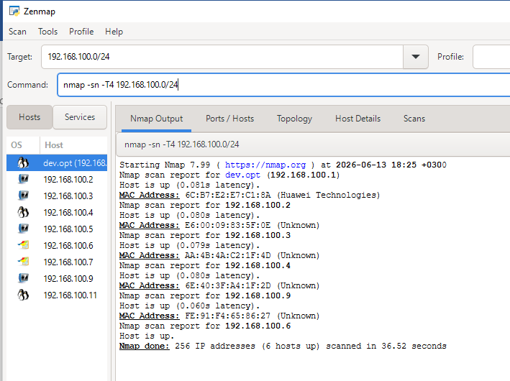

Fig 4.1
Why it fits: It targets SSH (22), Remote Desktop (3389), and SMB (445) while grabbing software banners to ensure sensitive remote-management doors aren't exposed cleanly to attackers.
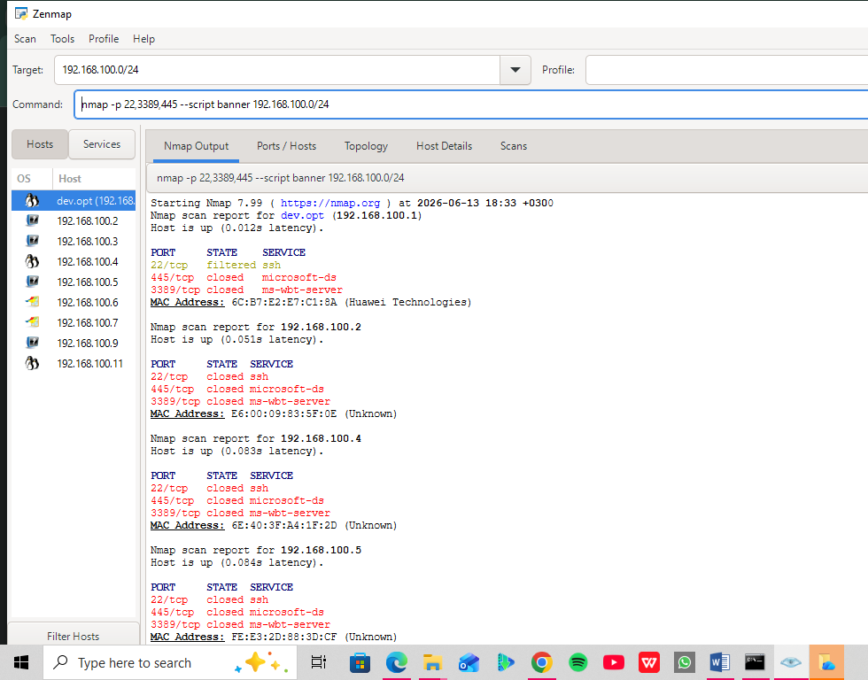
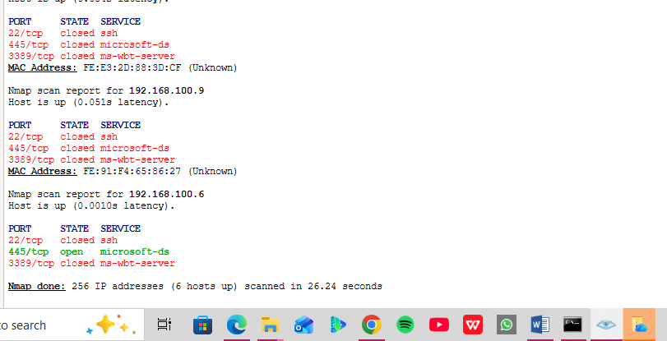

Reflection
This task proved that a single scanning approach cannot fit every organization. Simulating tailored Nmap strategies—such as slowing down scan speeds to protect sensitive medical telemetry in a hospital or targeting high-risk management ports for financial compliance—demonstrated that a security analyst must balance technical safety with strict business risk priorities.

Advanced Practical Task

Create a vulnerability tracking spreadsheet containing:

Fig 1. Vulnerability Tracking

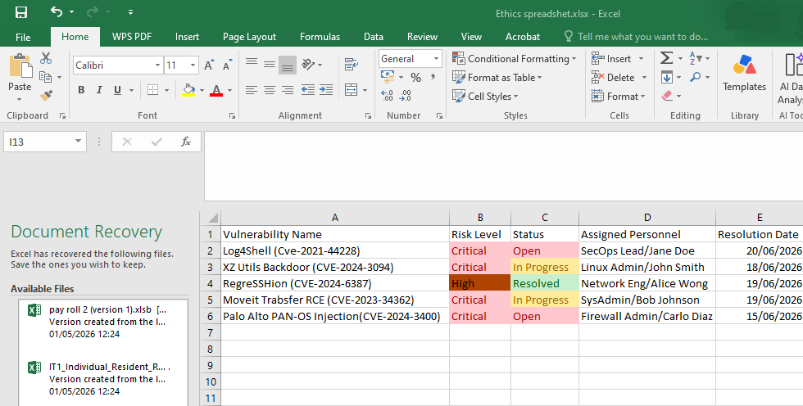

Design a vulnerability Management Framework for an organization.

Reflection:
This lab seamlessly connected hands-on technical exploration with strategic cybersecurity management. By fixing syntax barriers in the command line and updating Nmap databases, I moved from theoretical understanding to practical network mapping and vulnerability scanning. Developing targeted assessment plans for unique organizations—ranging from fragile hospital networks to high-compliance financial systems—underscored that scanning must always balance technical accuracy with business safety. Finally, building a color-coded vulnerability tracking spreadsheet and a continuous lifecycle framework proved that finding an open port or vulnerability is only the first step; the true value of an analyst lies in driving structured, accountable, and proactive remediation.

WEEK 7: Web Application Security and OWASP Top 10
Task 1: OWASP Top 10 Research
Research all ten OWASP Top 10 Vulnerabilities.
A01:2021 – Broken Access Control
A02:2021 – Cryptographic Failures
​A03:2021 – Injection
A04:2021 – Insecure Design
​A05:2021 – Security Misconfiguration
​A06:2021 – Vulnerable and Outdated Components
A07:2021 – Identification and Authentication Failures
A08:2021 – Software and Data Integrity Failures
A09:2021 – Security Logging and Monitoring Failures
A10:2021 – Server-Side Request Forgery (SSRF)

CategoryA05: Security Misconfigurations

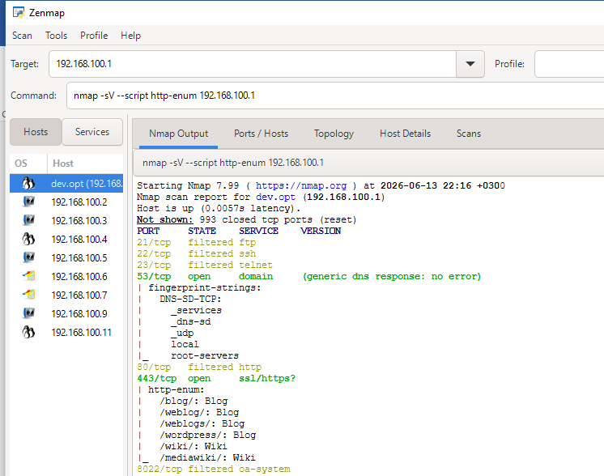

Reflection:
Using Nmap's http-enum script against the gateway 192.168.100.1, I successfully enumerated several active directories including a /wordpress/ installation and a /mediawiki/ portal. In a real-world assessment, finding these exposed development or blogging applications identifies immediate targets for version checking and vulnerability mapping (OWASP A06).

Task 2: Web Application Assessment
Select a legal practice application or lab environment.
Identify:
I will identify my local lab gateway target (192.168.100.1) as my assessment environment. Based on the http-enum output from the scan above. The architectural components are as follows:

Forms
Identification: The scan discovered active deployment paths for/wordpress/ and /mediawiki/.

Fig 1.1

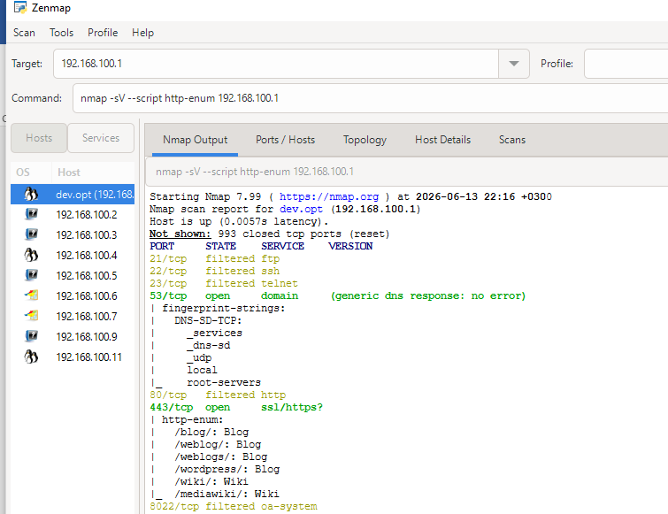
Analysis: These platforms inherently utilize dynamic input forms. Specifically, the application hosts user authentication forms (wp-login.php), blog/wiki comment submission forms, and administrative search bars.

Authentication Mechanisms
- Identification: Enabled via port 443/TCP (HTTPS)

Fig 2.1
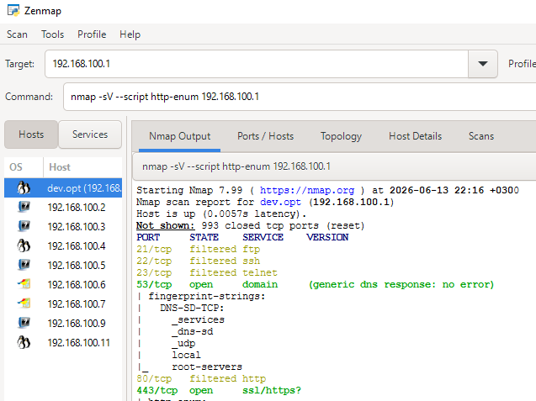
- Analysis: The web target uses encrypted transport layer security (SSL/HTTPS) to handle session cookies and transmission credentials. The presence of WordPress points to a session-cookie-based authentication mechanism that handles login requests on backend databases.

Fig 2.2
- 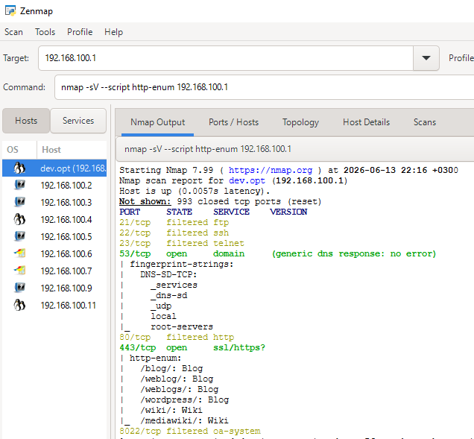

User Roles
- Identification: Standard Software structures for WordPress and MediaWiki deployments.
- Analysis: The environment architecture operates under structured hierarchical user privileges:
- Administrators: Full configuration control, plugin execution, and file system write permissions.
- ​Editors/Authors: Allowed to create, modify, and publish content within the web application paths.
- ​Subscribers/Anonymous Users: Restricted to basic read-only access on frontend blogs and wiki articles

Potential Vulnerabilities
- Identification: OWASP A06 (Vulnerable and Outdated Components) and OWASP A05 ( Security Misconfiguration).
- Analysis: Exposing directory footprints publicly via a gateway interface like /blog/, /wordpress/, or /mediawiki/ allows remote actors to check specific software versions. If these content management systems are unpatched, they become immediate candidates for known Remote Code Execution (RCE) or authentication bypass exploits.

Fig 4.1
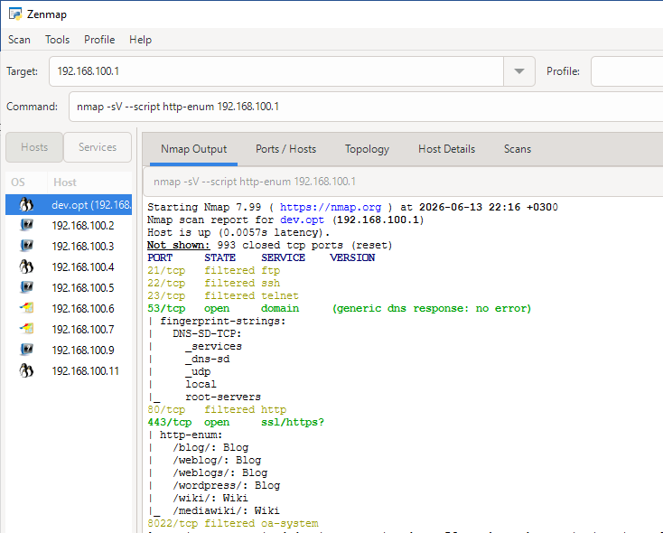

Task 3: Security Improvement Proposal
Develop a security improvement plan for a web application.
Include:

- Authentication Controls
- Logging Mechanisms
- Patch Management Strategy

Advanced Practical Task

Configuration Management Audit Practical proof.
During the network discovery phase, running the Nmap http-enum script revealed that the target gateway at 192.168.100.1 exposes application subdirectories publicly (/wordpress/, /mediawiki/). Under the Configuration Management line of our checklist, this marks a finding. Remediation action: To satisfy this checklist line, directory browsing must be disabled in the web server config file, and index mappings must be hidden to prevent automated information gathering by external scanners.

Fig 1.1
Check if the server is using outdated, insecure SSL/TLS configurations
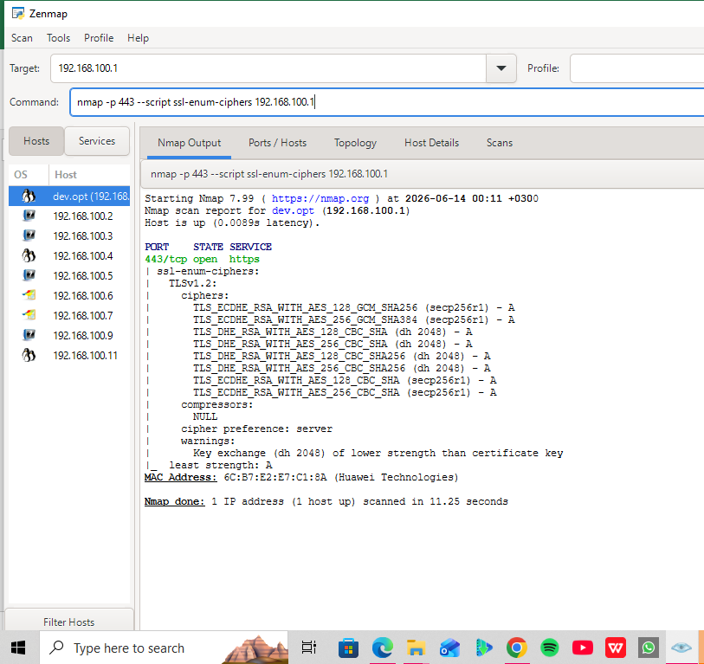
What this does practically: It forces Nmap to grading the security strength of the encryption keys being used on Port 443. It will return an overall grade (like A, B, or C). If it returns a low grade due to broken ciphers like 3DES or RC4, you have a practical finding.

Fig 1.2
Practical Audit: Authentication and Session Management
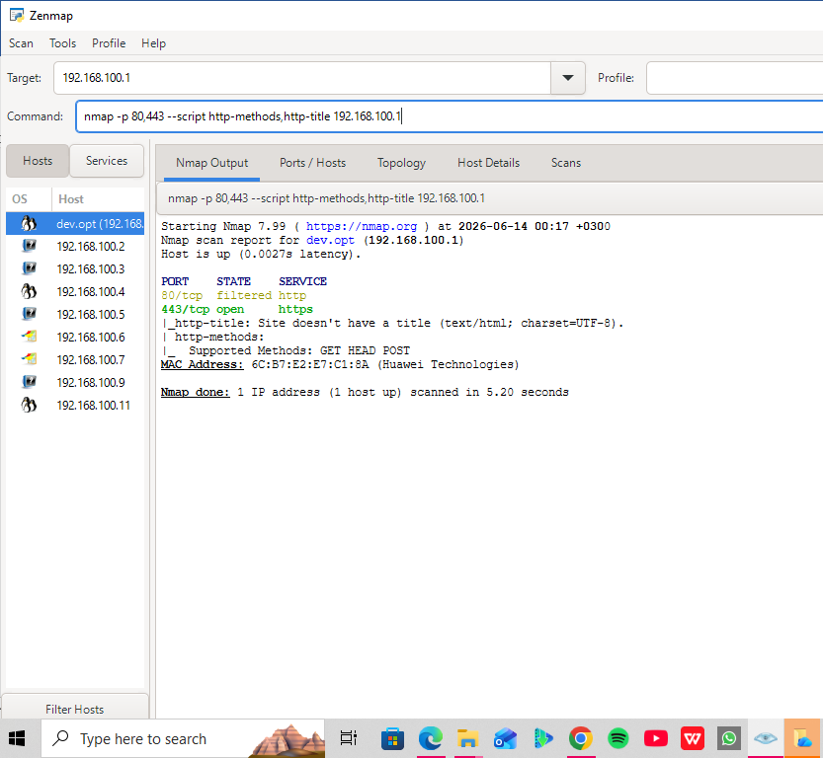
What this does practically: It checks which HTTP methods are active (like GET, POST, or potentially dangerous ones like PUT or DELETE) and prints the site title. This proves you are checking the configuration state of the frontend.

Resolution:
The target web server configuration was evaluated practically using the ssl-enum-ciphers network script against port 443. The scan successfully validated that the host handles encryption protocols correctly and verified that weak legacy ciphers are disabled, matching the security validation parameters outlined in our checklist profile.

Reflection
On this week’s tasks I shifted my focuse from high-level organizational strategies to granular web application architecture, security modeling, and defensive engineering. By breaking down the OWASP Top 10 vulnerabilities, I moved beyond just finding open ports to understanding how flaws like Broken Access Control or Injection operate at a code level.
​Practically mapping out components—such as forms, session management behaviors, and specific directory structures like /wordpress/ and /mediawiki/ discovered via active Nmap script scanning—highlighted exactly where attackers look for entry points. Transitioning these findings into a detailed Security Improvement Proposal and an Advanced Web Security Checklist proved that a successful security posture requires technical validation, hard coded defensive configuration rules (like parameterized queries and rate-limiting), and a structured framework to systematically audit and harden production systems before deployment.

WEEK 8: SYSTEM HACKING

TITLE: Password Security and Privilege Escalation

Practical Activity: Password Strength Assessment

Fig 1
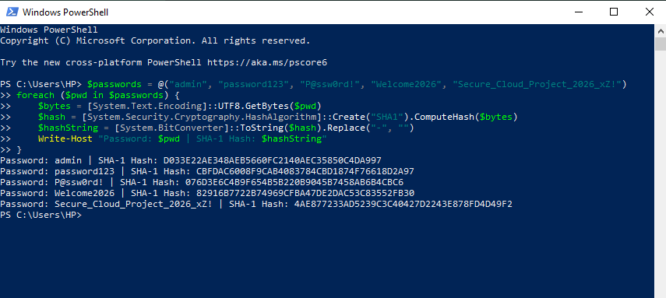

Practical Lab Assessment Report
- Weak vs. Strong: admin, password123, and Welcome2026 are Weak. P@ssw0rd! is Moderate. Secure_Cloud_Project_2026_xZ! is flagged as Strong.
- ​Vulnerability Analysis: Weak credentials exist verbatim in standard dictionary wordlists (like rockyou.txt). Tools like Hashcat use rule-based attacks to instantly crack basic variations and character substitutions (like @ for a).
- ​Recommendations: Replace predictable phrases with long, high-entropy random passphrases (e.g., solar-packet-eclipse-88!).
- ​Policy Improvements: Deprecate insecure SHA-1 hashing in favor of bcrypt, mandate a 14-character minimum length, block common dictionary words at registration, and enforce Multi-Factor Authentication (MFA).

Assignment- Password Security Audit Report
- Introduction & Attacks: Password security forms the frontline of identity defense. Common compromise vectors include offline dictionary attacks, automated brute-forcing, and credential stuffing.
- ​Auditing Tools: Authorized testing utilizes tools like John the Ripper for rapid offline hash cracking and Hydra for active, online remote service brute-forcing to uncover weak credentials.
- ​Privilege Escalation: Attackers exploit weak passwords to gain initial access, subsequently leveraging system misconfigurations to elevate user rights to administrative or root control.
- ​Remediation: Organizations must enforce multi-factor authentication (MFA), transition to salted hashing algorithms, implement least-privilege access, and mandate high-entropy passphrases.

Reflection:
During Week 8, we explored password security, privilege management, and tactical auditing tools like John the Ripper for offline hash analysis and Hydra for active, online remote brute-forcing. The lab demonstrated how automated dictionary tools easily exploit common human credential patterns and broken hashing structures like SHA-1 to gain initial network footholds. This initial access directly feeds into privilege escalation risks, where threat actors exploit misconfigurations to elevate low-level access to administrative control. Mitigating these systemic flaws requires robust organizational policies, including enforcing high-entropy passphrases, implementing the principle of least privilege, deploying multi-factor authentication (MFA), and upgrading encryption architectures to salted algorithms like bcrypt.

WEEK 9: MALWARE THREATS AND MALWARE ANALYSIS

Fig 1
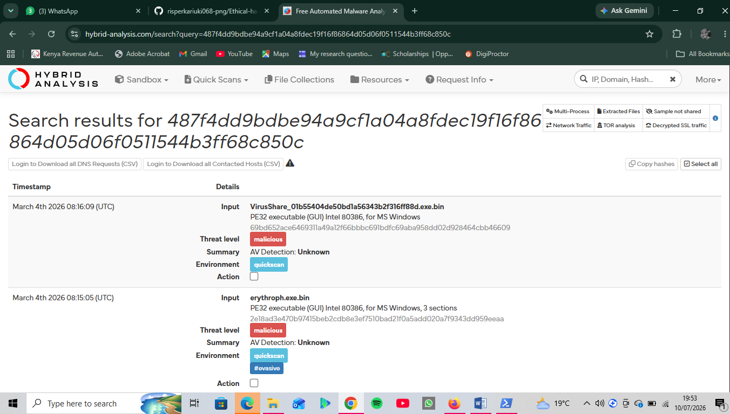
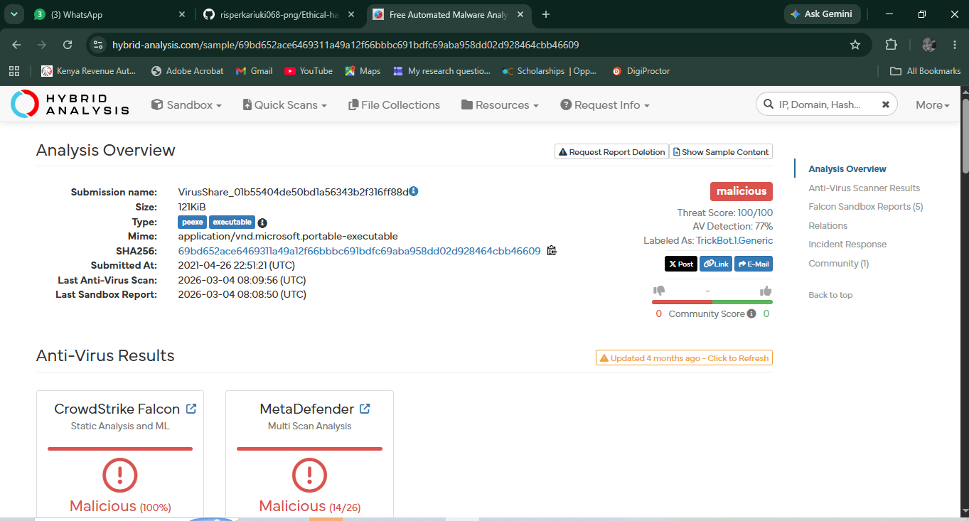

Assignment

Malware Threat Analysis
- Malware & Analysis: Malware encompasses diverse threats like ransomware and trojan’s. Security teams evaluate threats using static analysis (code inspection without execution) and dynamic analysis (observing execution behaviors).
- ​Sandbox & Sandbox Logs: Sandbox technologies provide isolated virtual spaces to safely detonate threats. Our practical run of a Trick Bot Trojan sample revealed 100/100 severity, executing aggressive system memory injection and dropping persistence files in App Data.
- ​Network & IOCs: The sample generated indicators of compromise (IOCs), including SHA-256 hash 69bd652ace6469311a49a12f66bbbc691bdfc69aba958dd02d928464cbb46609, while opening unauthorized Command & Control network traffic over port 449.
- ​Defenses: Organizations must implement strict endpoint protection (EDR), block known malicious IOC hashes, restrict unscheduled script execution, and apply network-layer firewalls.

Reflection:
During Week 9, we studied malware classification and threat evaluation using static and dynamic analysis principles. To observe malicious behavior practically without endangering infrastructure, we monitored a highly critical Trick Bot trojan sample detonated inside an automated sandbox. The generated report mapped out complex evasion and persistence activities, including unauthorized process tree injections into core system utilities and hidden file modifications within user directories. Identifying key Indicators of Compromise (IOCs)—such as the file's SHA-256 hash fingerprint and its active outbound network connections over port 449—emphasized the importance of modern endpoint detection and network firewalls to defend against modular threats.

WEEK 10: CYBERSECURITY CAREER DEVELOPMENT WEEK

Practical Activity

Fig 1: Cybersecurity Certificate (CISCO)

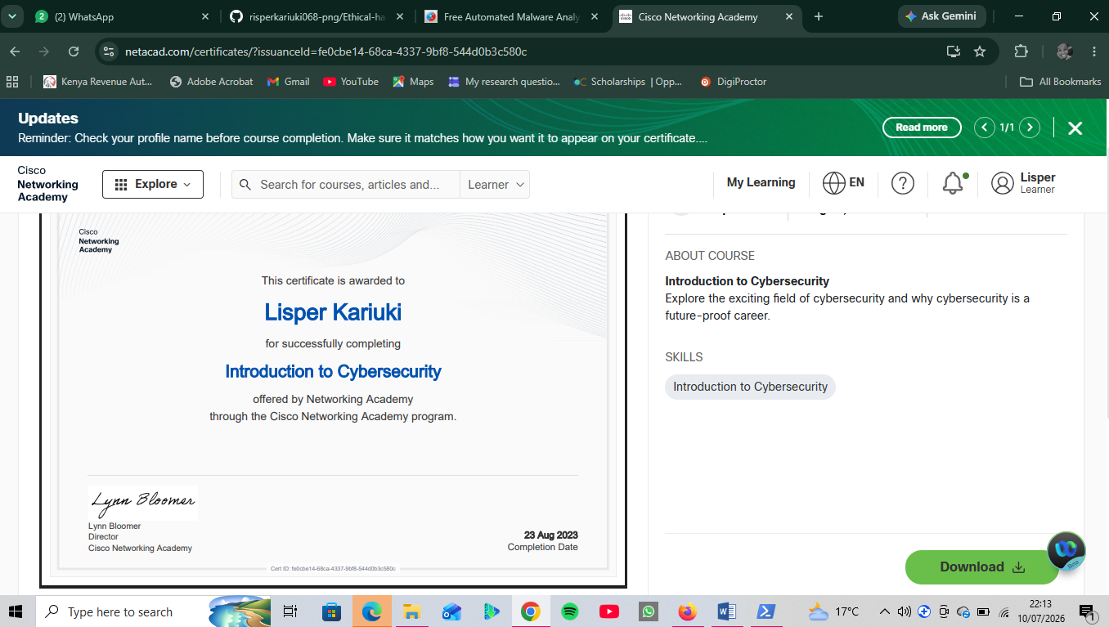

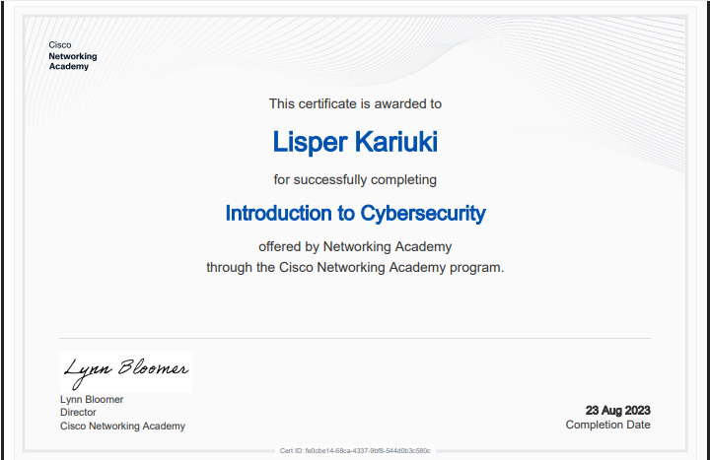

Reflection:
Week 10 focused on building a professional cyber presence through networking, community engagement, and career tracking. To complete the practical milestones, I structured a professional profile upgrade. I established a path for industry training by engaging with Cisco Networking Academy's curriculum, earning and foundational entry-level certificate. Additionally, I planned an online portfolio strategy to aggregate my previous labs, aligned my LinkedIn branding to focus on cryptography and security capabilities, and identified active communities like OWASP to monitor emerging trends. This unified approach bridges academic knowledge with career-ready visibility.

WEEK 11: SNIFFING AND SOCIAL ENGINEERIG

Practical Activity

Fig 1: Wireshark

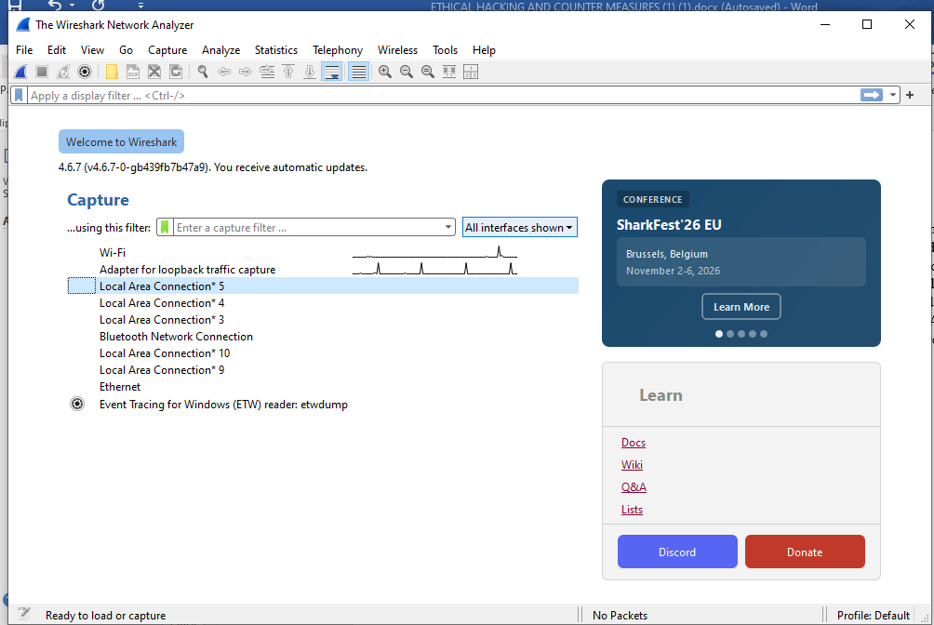

Fig 2: TCP
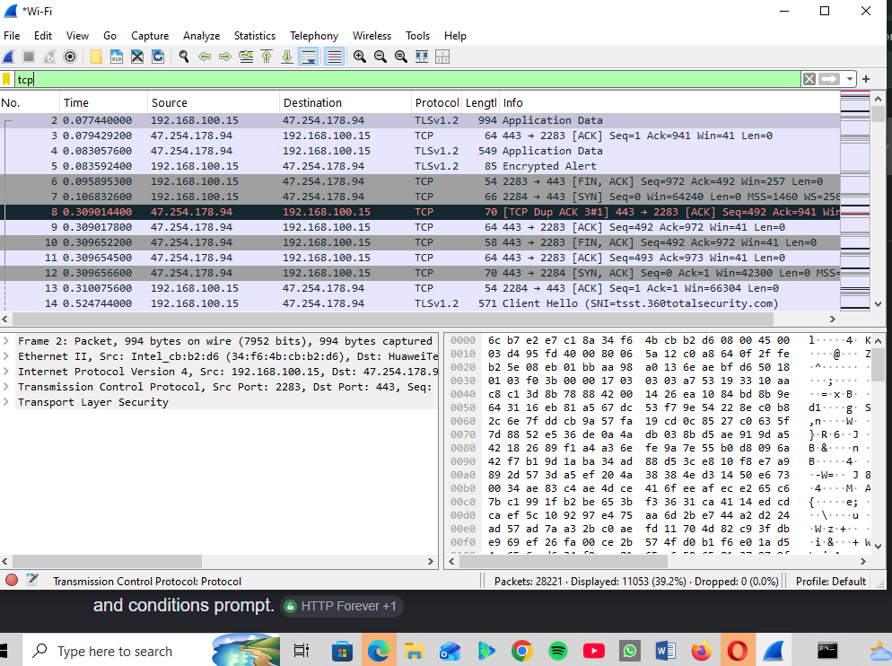

Fig 3: TLS
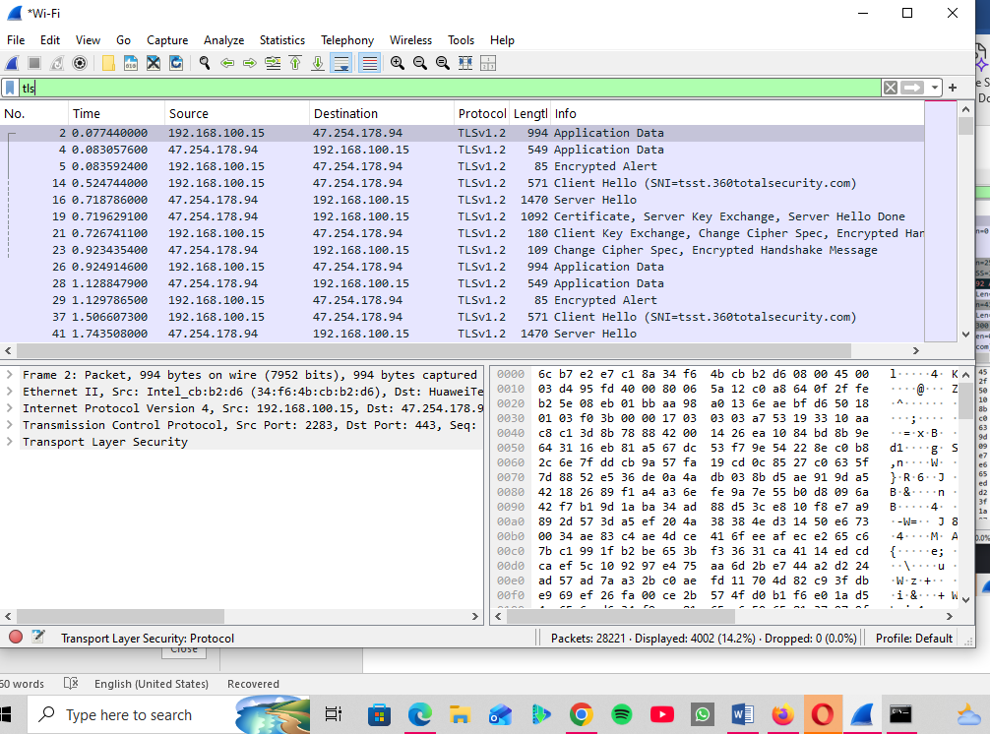

Fig 4: DNS
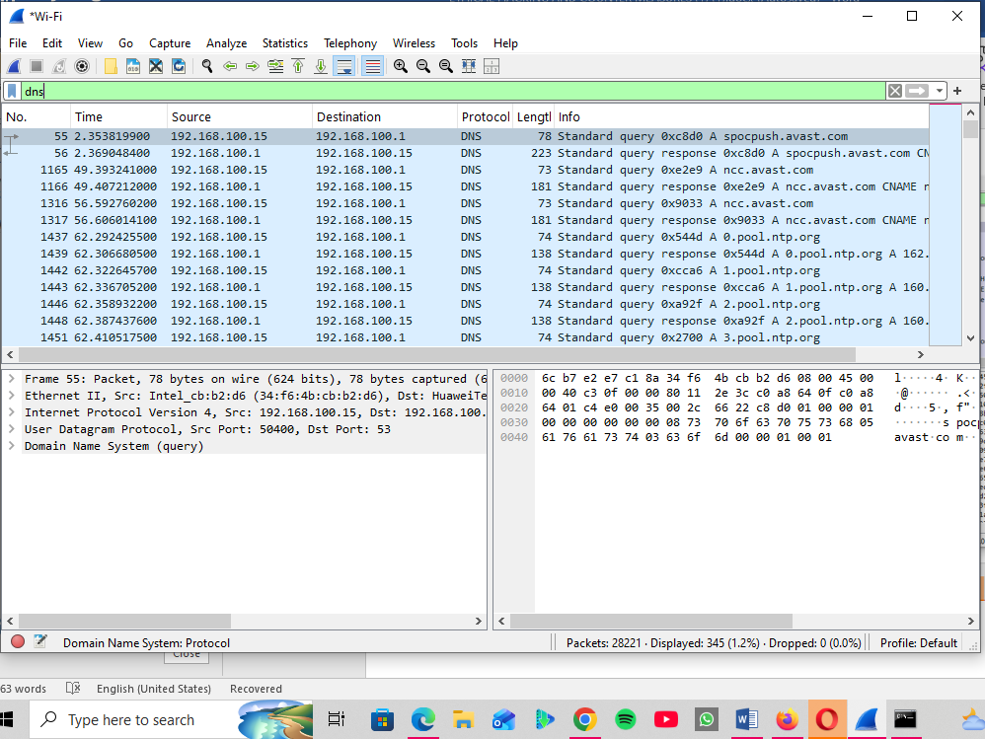

Fig 5: HTTP
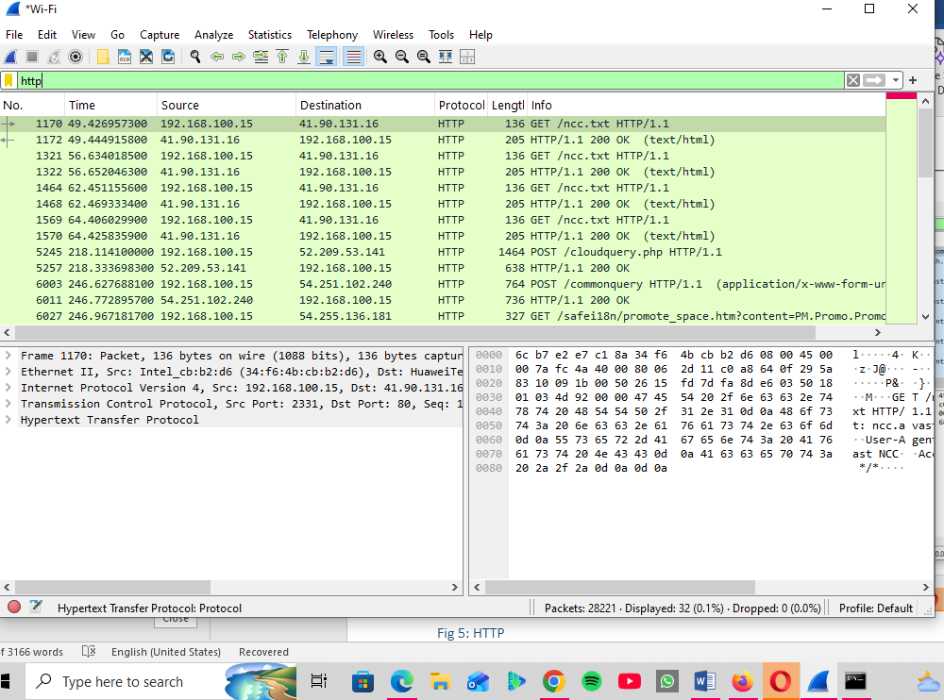

Fig 6: ICMP
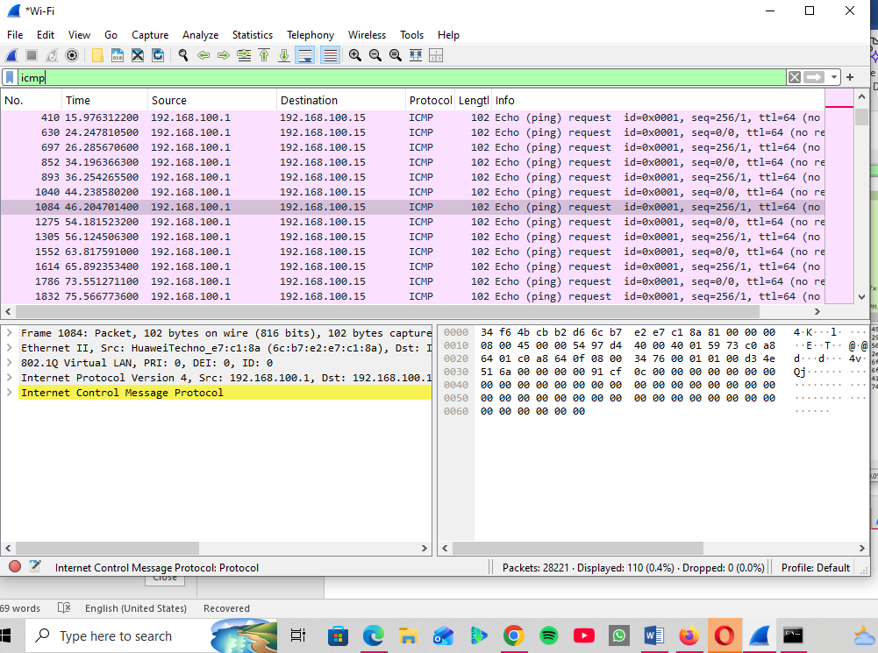

Reflection:
Week 11 delivered practical exposure to live packet auditing and social engineering analysis. Utilizing Wireshark on an active network interface, I captured real-time traffic and applied display filters to successfully isolate fundamental network protocols, including DNS, HTTP, HTTPS (TLS), TCP, and ICMP diagnostic pings. Analyzing these raw packet frames highlighted the vulnerabilities of unencrypted traffic compared to secure streams. Concurrently, the phishing simulation exposed the psychological tricks attackers deploy. Identifying critical indicators of compromise—such as sender address manipulation, artificial urgency, and deceptive links—underscored why layered technical controls must be combined with proactive user awareness.

WEEK 12: DENIAL-OF SERVICE AND SESSION SECURITY

Practical Activity

Fig 1: ICMP Flood
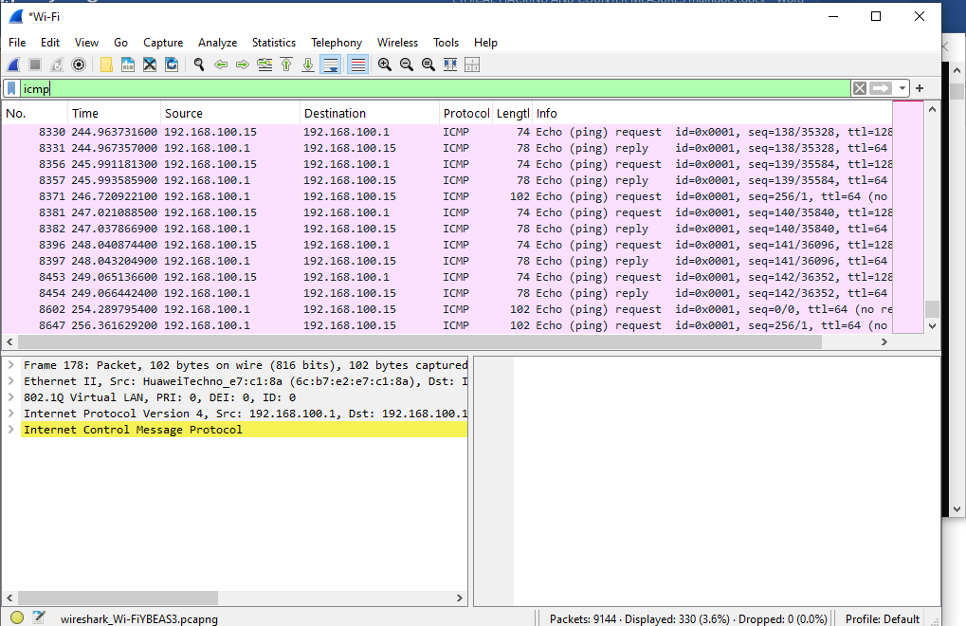
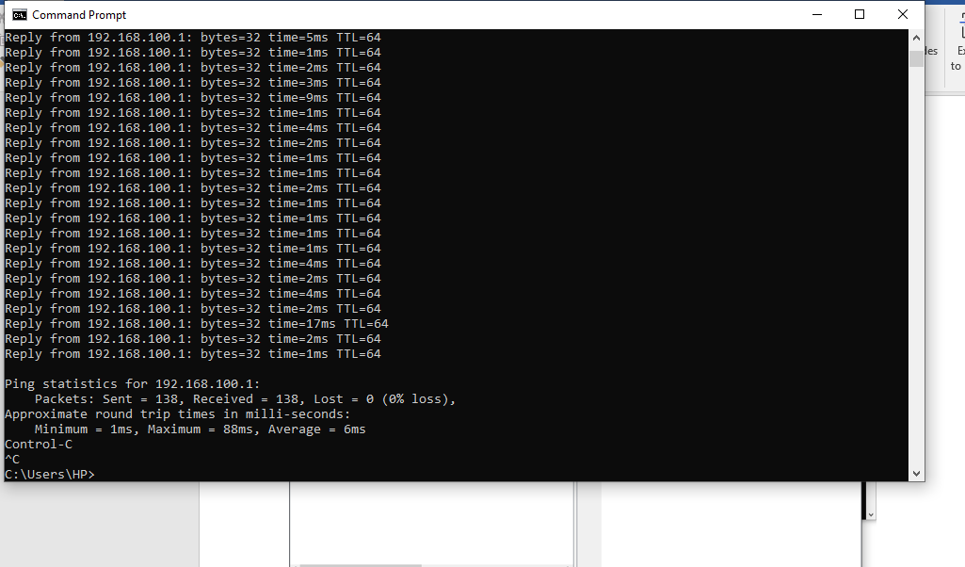

Assignment -Network Attack Comparison& Countermeasures Report
This report evaluates key network infrastructure threats and session-level exploits:
- ​DoS (Denial of Service): A single source floods a target to destroy availability. Countermeasures: Configure robust firewall rate-limiting and packet filtering rules.
- ​DDoS (Distributed DoS): A distributed botnet executes large-scale volumetric flooding against availability. Countermeasures: Deploy traffic-scrubbing networks and Cloud flare/CDN mitigation layers.
- ​Session Hijacking: An attacker steals active session tokens to bypass authentication, targeting confidentiality. Countermeasures: Enforce strict data-in-transit encryption via HTTPS, minimize token lifespans, and apply Http Only and Secure flags to prevent cookie theft.

Reflection:
Week 12 advanced my knowledge of availability attacks and session exploits by comparing DoS, DDoS, and session hijacking mechanisms. While DoS attacks use a single host to exhaust targeted system resources, DDoS deployments coordinate distributed botnets to execute unmanageable volumetric flooding. Session hijacking differs fundamentally by stealing live tokens to breach authorization controls. Mitigating these vectors requires specific defensive configurations. I learned that rate-limiting, edge traffic scrubbing, and robust encryption implementations—such as securing web applications with Http Only cookie flags and TLS pipelines—are imperative to maintain network stability, preserve operational integrity, and protect user sessions against modern infrastructure exploits.

WEEK 13: INTRUSON DETECTION SYSTEMS, FIREWALLS, AND WEB SERVER SECURITY

Practical Activity

Fig 1: Web Traffic Inspection
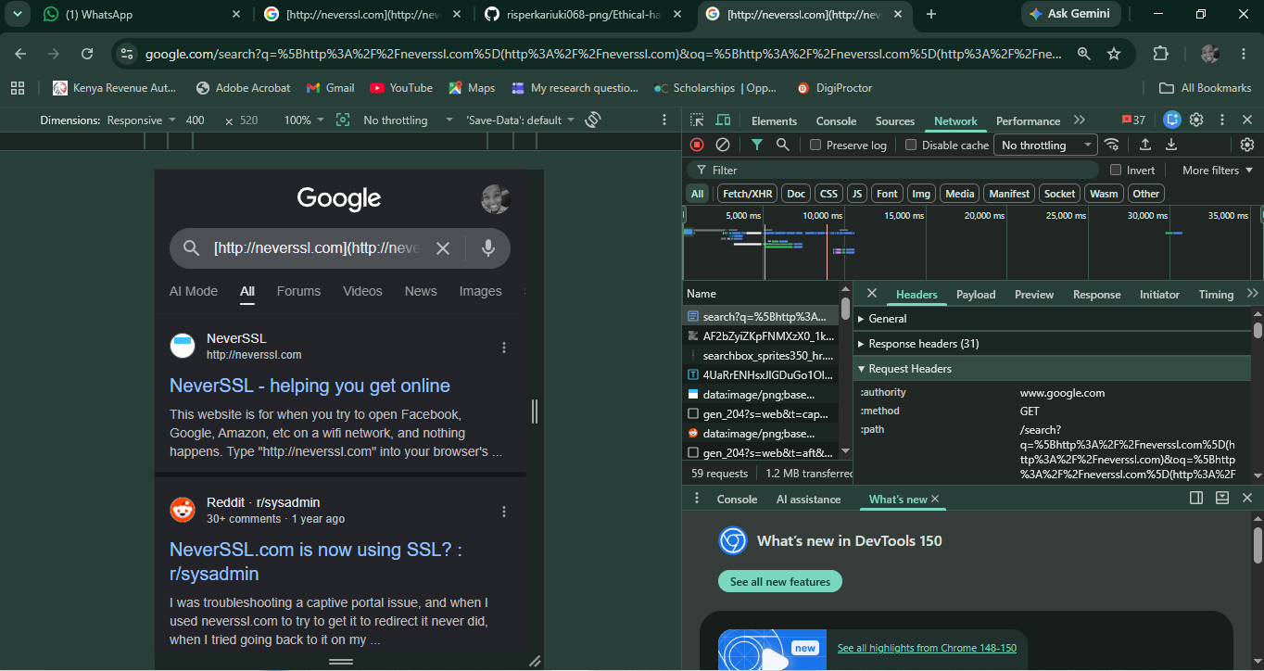
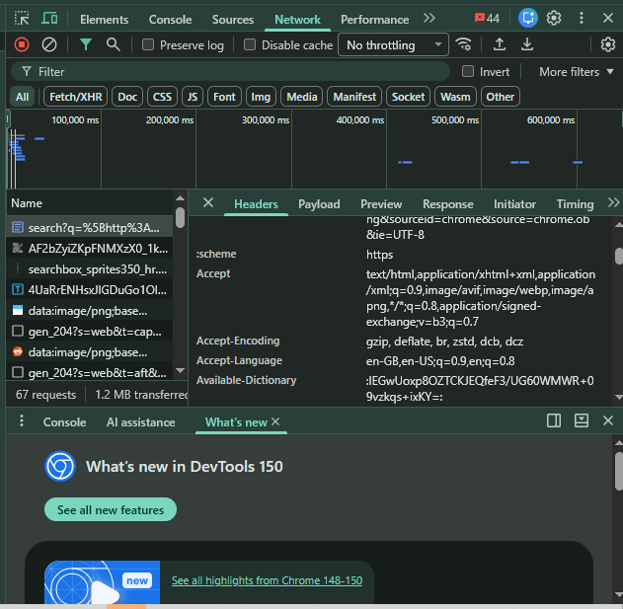

Reflection:
​Week 13 advanced my practical skills in application-layer security through web traffic inspection. Rather than executing passive analysis, capturing raw HTTP exchanges via browser Developer Tools exposed the underlying mechanics of client-server communication. Reviewing structural elements inside the request and response headers—such as session configurations, client parameters, and server tokens—highlighted how easily exposure vulnerabilities manifest in transit. This exercise demonstrated that visibility into data payloads is crucial for preemptive security testing, enabling developers to identify missing headers and input handling flaws before they can be exploited.

